Event 2000.07.28 – (2000-210)

Particle event: To(Ep>10 MeV) – 28d02^{h}
Tmax₁(Ep>10 MeV) – 28d06^{h}, Jmax₁(Ep>10 MeV) – 5 /cm².s.sr
Tmax₂(Ep>10 MeV) – 28d12^{h}, Jmax₂(Ep>10 MeV) – 13 /cm².s.sr
Duration of the event – 3 days
Energy of the SCR and 0.1 GCR fluxes balance – Eb(max₁) = 140 MeV
– Eb(max₂) = 105 MeV
Sources:  solar flare 27d23^{h}37^{m}, M1.2/SF, N11W78, АR9090
Main X-ray burst 1-8 Ǻ: onset – 27d23^{h}37^{m},max – 27d23^{h}42^{m}, Ф = 0.0044 J/m²
CME: 28d00^{h}54^{m}, V = 0447 km/s, Δφ = 057º; dA = 296º
▲ SC 28d06^{h}34^{m}

Particle fluxes and associated phenomena
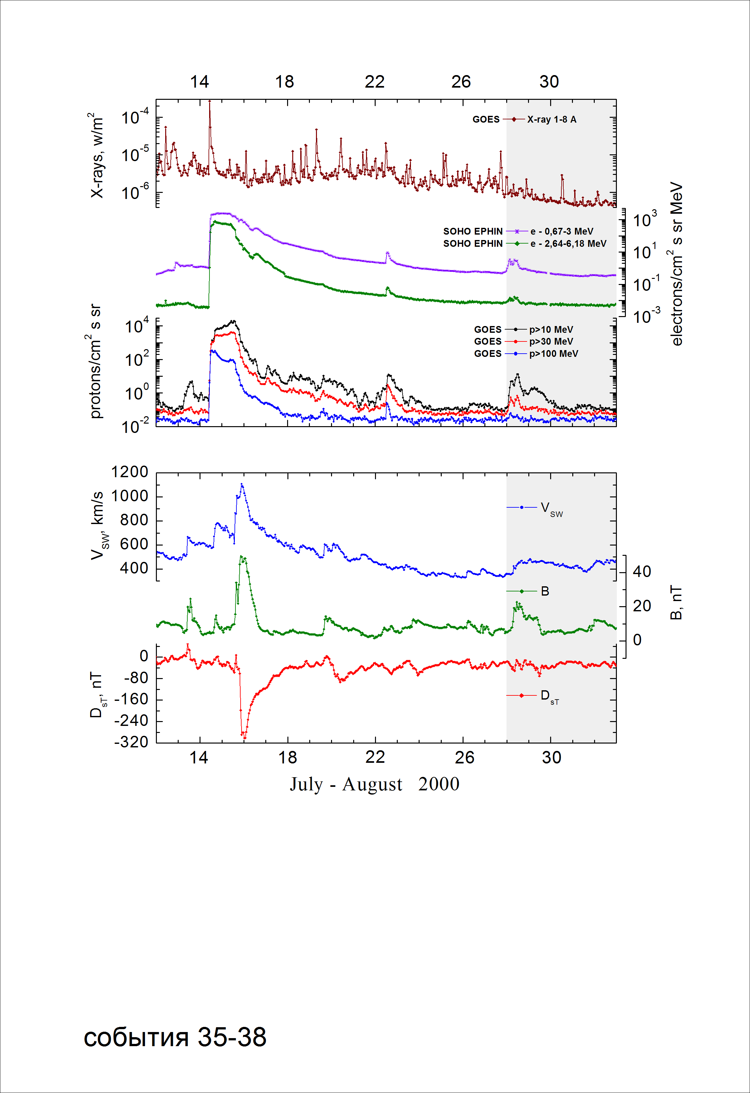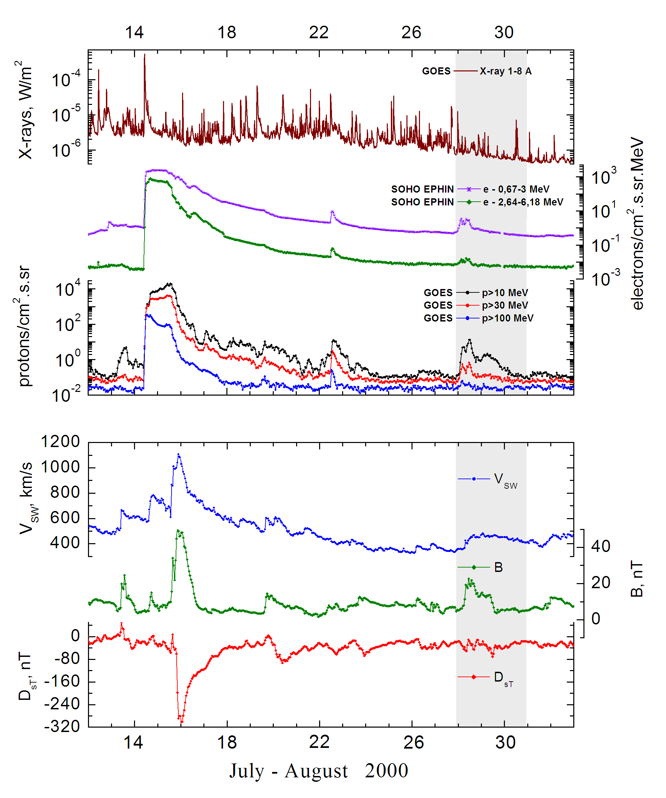

Integral time-of-maximum proton spectrum
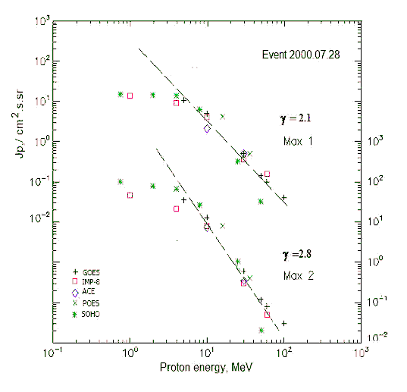

Integral fluxes of protons for the event of 2000 July 28

S/c, instruments | Eр, MeV | To | Tmax | Jmax,  /cm².s.sr | Dura-tion | Comments
GOES-10
EPS | >5 | 02^{h} | 06 ^{h}/12^{h} | 10.7/36 | 3d
EPS | >10 | 02^{h} | 06 ^{h}/12^{h} | 5/13 | 3d
EPS | >30 | 02^{h} | 04 ^{h}/11^{h} | 0.5/0.6 | 2d
EPS | >50 | 02^{h} | 04 ^{h}/11^{h} | 0.14/0.12 | 1d
EPS | >60 | 02^{h} | 04^{h}/11^{h} - | 0.1/0.08 | 1d
EPS | >100 | 02^{h} | 04^{h}/11^{h} - | 0.04/0.03 | 1d
POES-16
MEPED | >0.24 | - | - | - | -
MEPED | >0.8 | - | - | - | -
MEPED | >2.5 | - | - | - | -
MEPED | >6.9 | - | - | - | -
MEPED | >16 | - | 04^{h}/12^{h} | 4.2 / 8.2 | 2d
MEPED | >36 | - | 04^{h}/12^{h} | 0.5 / 0.4 | 1d
MEPED | >70 | - | - | - | -
MEPED | >140 | - | - | - | -
IMP-8
CPME | >1 | <3^{h} | 04 ^{h}/11 ^{h} | 14/48 | 2d
CPME | >4 | <3 ^{h} | 04 ^{h}/11 ^{h} | 9/21.7 | 2d
CPME | >10 | <3 ^{h} | 04 ^{h}/11 ^{h} | 4/8.2 | 2d
CPME | >30 | <3 ^{h} | 04 ^{h}/11 ^{h} | 0.35/0.3 | 1d
CPME | >60 | <3 ^{h} | 04 ^{h}/11 ^{h} | 0.16/0.05 | 1d
ACE
SIS | >10 | 2 ^{h} | 03 ^{h}/11 ^{h} | 2.1/7.5 | 1d
SIS | >30 | 2 ^{h} | 03 ^{h}/10 ^{h} | 0.55/0.35 | 1d
SOHO
EPHIN (INT) | >50 | 00^{h} | 04^{h}/12^{h} | 0.03/0.02 | 1d

Differential fluxes of protons for the event of 2000 July 28

S/c, instruments | ∆Е, MeV | To | Tmax | Jmax  /cm².s.sr.MeV | Dura-tion | Comments
IMP-8
CPME | 1-2 | 01^{h} | 06^{h}/12^{h} | 3.8/15 | 1d
CPME | 2-4.6 | 01^{h} | 04^{h}/12^{h} | 1.96/8.5 | 1d
CPME | 4.6-15 | 01^{h} | 04^{h}/11^{h} | 0.54/1.56 | 1d
CPME | 15-25 | 01^{h} | 04^{h}/11^{h} | 0.2/0.39 | 1d
CPME | 25-48 | 01^{h} | 04^{h}/11^{h} | 0.016/0.02 | 1d
CPME | 48-96 | 00^{h} | 04^{h}/11^{h} | 0.002/0.0016 | 1d
CPME | 96-145 | 00^{h} | - | - | -
CPME | 145-440 | - | - | - | -
SOHO
LION | 0,75-2 | 01^{h} | 04^{h}/12^{h} | 0.38/13.2 | 4d
LION | 2-6 | 01^{h} | 04^{h}/12^{h} | 0.16/3.1 | 4d
EPHIN | 4-8 | 01^{h} | 04^{h}/12^{h} | 0.4/10 | 4d
EPHIN | 8-25 | 01^{h} | 04^{h}/12^{h} | 0.11/1.5 | 4d
EPHIN | 25-41 | 01^{h} | 04^{h}/12^{h} | 0.011/0.04 | 4d
EPHIN | 41-53 | - “ - | - “ - | - “ - | - “ -

References:
No information on publications, excepting for:
http://www.swpc.noaa.gov/ftpdir/indices/SPE.txt

Замечания: 2000.07.28

