Event 2001.12.30 – (2001-364)

Particle event: To(Ep>10 MeV) – 30d20^{h}
Tmax₁(Ep>10 MeV) – 31d02^{h}, Jmax₁(Ep>10 MeV) – 25.5 /cm².s.sr
Tmax₂(Ep>10 MeV) – 31d16^{h}, Jmax₂(Ep>10 MeV) – 75 /cm².s.sr
Duration of the event – 3 days
Energy of the SCR and 0.1 GCR fluxes balance – Eb(max₁₎ = 190 MeV
– Eb(max₂₎ = 170 MeV
Sources: □ solar flare 29d19^{h}50^{m}, M1.8/, S08W90, АR9748
□ solar flare 29d22^{h}56^{m}, M2.8/1F, S24E88, АR9767
Ø solar flare 30d21^{h}53^{m}, C4.2/1F, S24E77, АR9767
Main X-ray burst 1-8 Ǻ: onset – 29d19^{h}50^{m}, max – 29d21^{h}27^{m}, Ф = 0.19 J/m²
CME: 29d20^{h}30^{m}, V=0819 km/s, Δφ = 211º; dA = 281º;
ΔSC 30d20^{h}29 ^{m}

Particle fluxes and associated phenomena
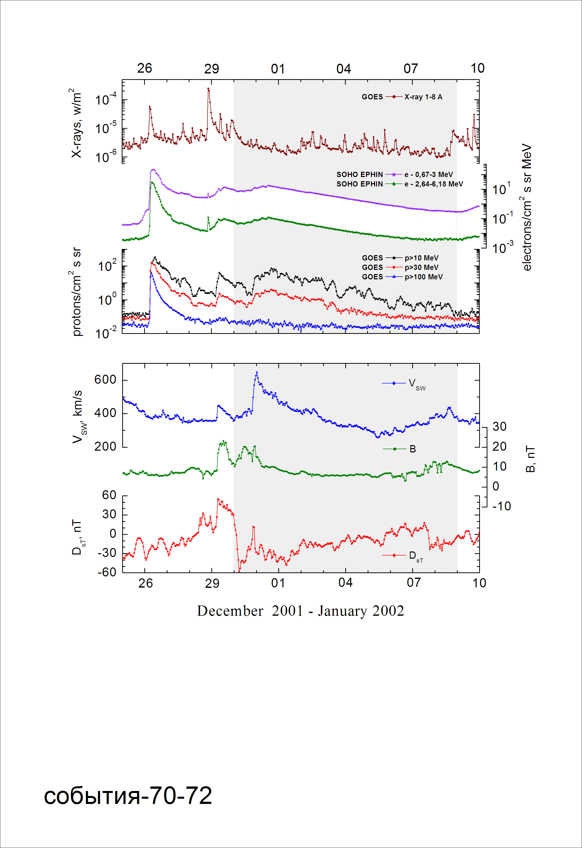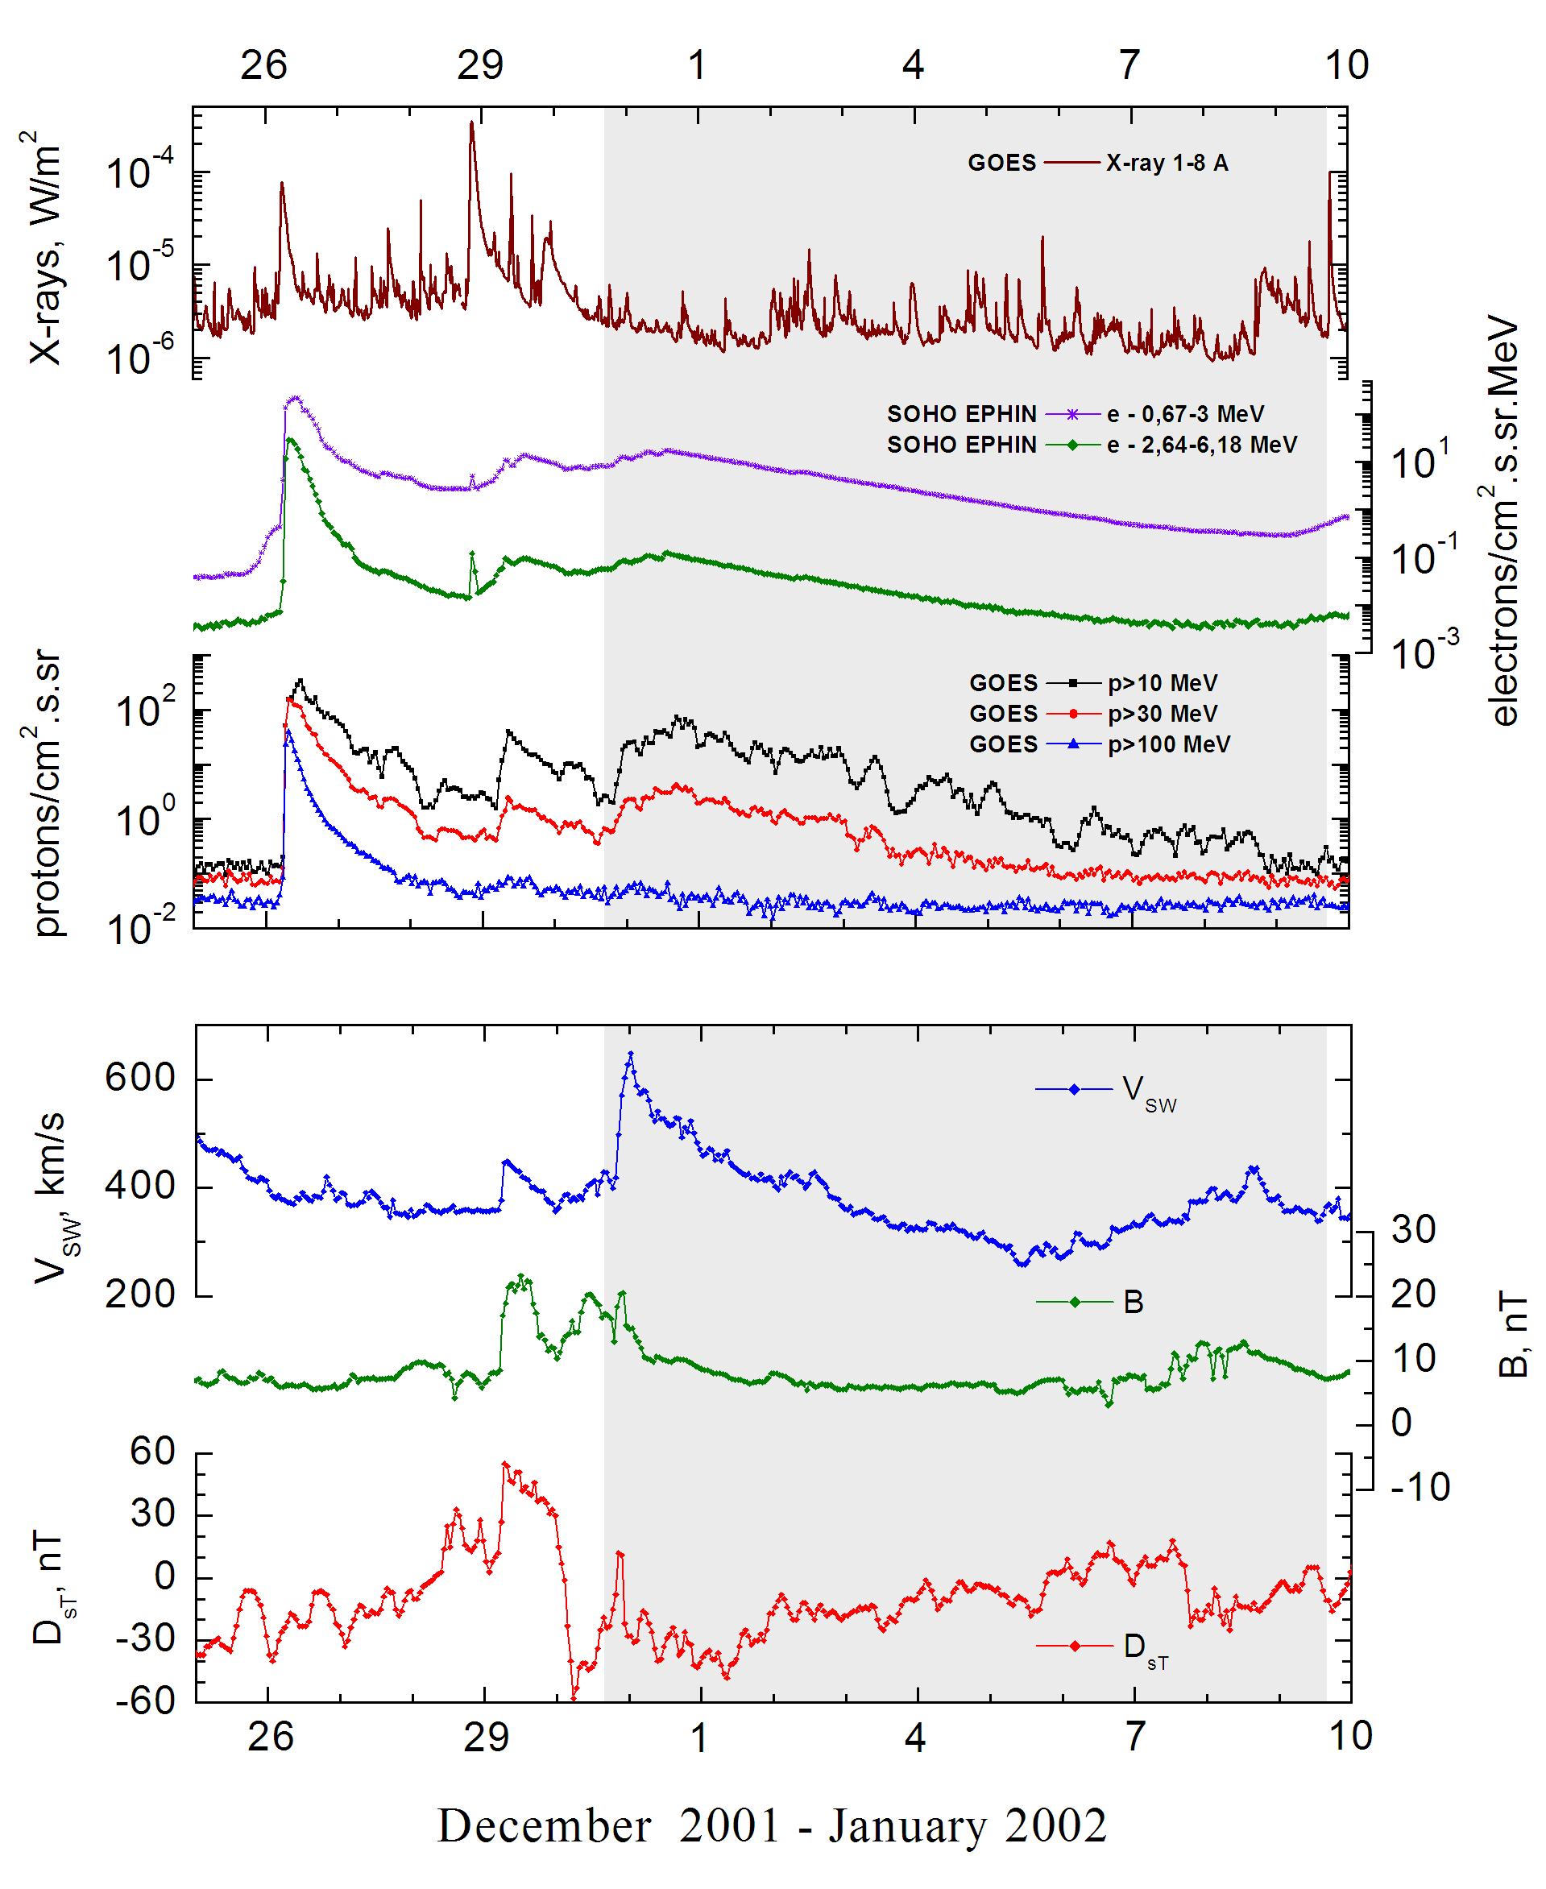
Integral time-of-maximum proton spectrum
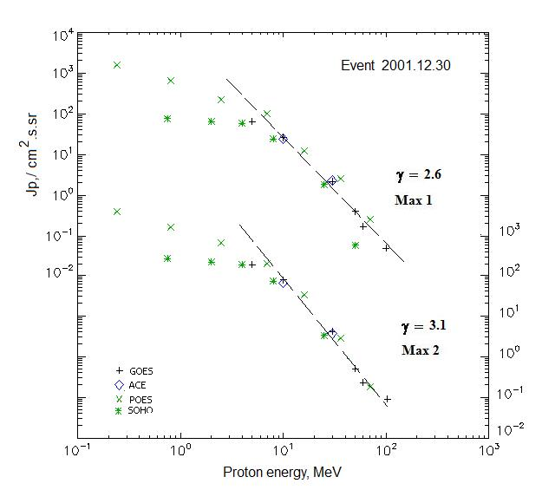

Integral fluxes of protons for the event of 2001 December 30

S/c, instruments | Eр, MeV | To | Tmax | Jmax,  /cm².s.sr | Dura-tion | Comments
GOES-10
EPS | >5 | 20^{h} | 31d02^{h}/31d16^{h} | 63.2/177 | 3d
EPS | >10 | 20^{h} | 31d02^{h}/31d16^{h} | 25.5/75 | 3d
EPS | >30 | 20^{h} | 31d02^{h}/31d16^{h} | 2.2/4.1 | 3d
EPS | >50 | 20^{h} | 31d02^{h}/31d16^{h} | 0.4/0.5 | 3d
EPS | >60 | 20^{h} | 31d02^{h}/31d16^{h} | 0.17/0.23 | 3d
EPS | >100 | 20^{h} | 31d02^{h}/31d16^{h} | 0.05 /0.1 | 3d
POES-16
MEPED | >0.24 | 20^{h} | 31d02^{h}/31d16^{h} | 1830/3.6∙10³ | 3d
MEPED | >0.8 | 20^{h} | 31d02^{h}/31d16^{h} | 625/1.5∙10³ | 3d
MEPED | >2.5 | 20^{h} | 31d02^{h}/31d16^{h} | 220/610 | 3d
MEPED | >6.9 | 20^{h} | 31d02^{h}/31d16^{h} | 110/194 | 3d
MEPED | >16 | 20^{h} | 31d02^{h}/31d16^{h} | 13/32.6 | 3d
MEPED | >36 | 20^{h} | 31d02^{h}/31d16^{h} | 2.5/2.8 | 3d
MEPED | >70 | 20^{h} | 31d02^{h}/31d16^{h} | 0.25 /0.18 | 3d
MEPED | >140 | - | - | - | -
ACE
SIS | >10 | 20^{h} | 31d00^{h}/31d16^{h} | 24/63.4 | 3d
SIS | >30 | 20^{h} | 31d00^{h}/31d16^{h} | 2.3 /3.6 | 3d
SOHO
EPHIN (INT) | >50 | - | 31d00^{h}/ - | 0.06/ - | -

Differential fluxes of protons for the event of 2001 December 30

S/c, instruments | ∆Е, MeV | To | Tmax | Jmax. /cm².s.sr.MeV | Dura-tion | Comments
SOHO
LION | 0.75-2 | 22^{h} | 31d02^{h}/31d15^{h} | 6.7/25.7 | 3d
LION | 2-6 | 20^{h} | 31d02^{h}/31d15^{h} | 1.7/6.4 | 3d
EPHIN | 4-8 | 21^{h} | 31d02^{h}/31d15^{h} | 8.4/27.6 | 3d
EPHIN | 8-25 | 20^{h} | 31d02^{h}/31d14^{h} | 1.3/3.9 | 3d
EPHIN | 25-41 | 20^{h} | 31d02^{h}/31d14^{h} | 0.08/0.15 | 3d
EPHIN | 41-53 | - “ - | - “ - | - “ - | - “ -

References:
Kuwabara T., J.W. Bieber, J. Clem, et.al., 2006.

