Event 2002.07.19 – (2002-200)

Particle event: To(Ep>10 MeV) – 19d05^{h}
Tmax(Ep>10 MeV) – 19d11^{h}, Jmax (Ep>10 MeV) – 3.6 /cm².s.sr
Duration of the event – 2 days
Energy of the SCR and 0.1 GCR fluxes balance – Eb = 215 MeV

Sources: ⊙solar flare 18d07^{h}24^{m}, X1.8/2B, N19W3 АR10030;
◊ flare activity of AR10039, 3d behind E-limb
Main X-ray burst 1-8 Ǻ: onset – 18d07^{h}24^{m}, max – 18d07^{h}44^{m}, Ф = 0/0056 J/m²
CME: 18d08^{h}06^{m}, V = 1099 km/s, ∆φ = 360º, dA = 354 º;
▲SC 19d11^{h}09^{m}

Particle fluxes and associated phenomena

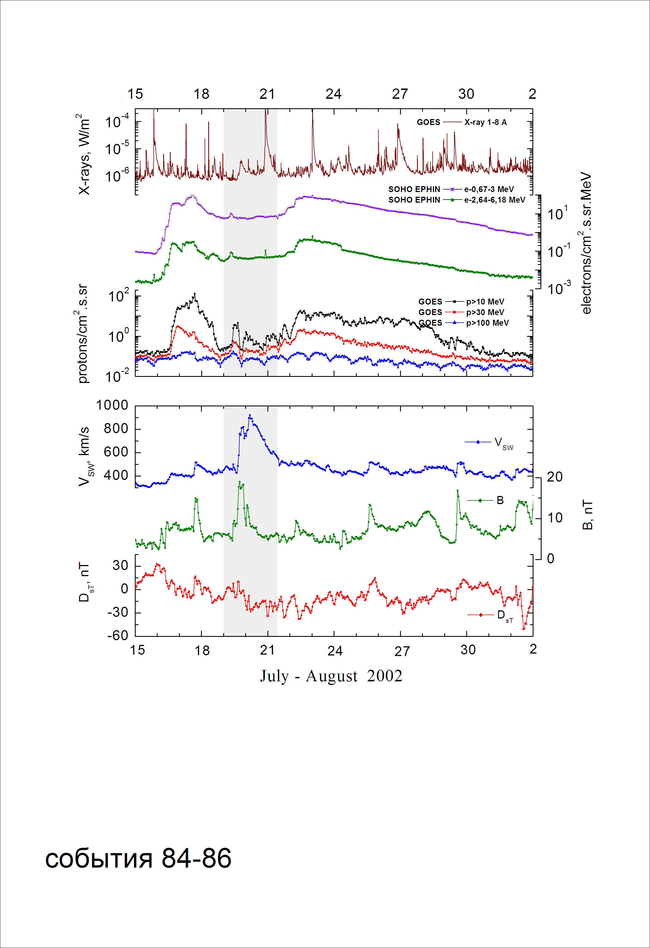
Integral time-of-maximum proton spectrum
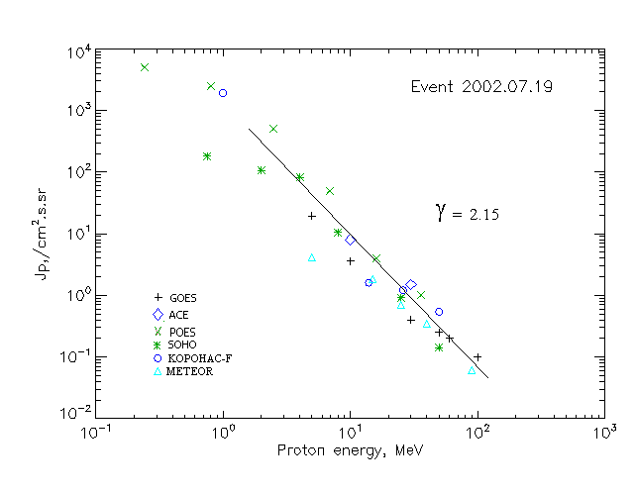

Integral fluxes of protons for the event of 2002.07.19

S/c,  instruments | Eр, MeV | To | Tmax | Jmax,  (cm².s.sr)⁻¹ | Dura-tion | Comments
GOES-10
EPS | >5 | 05^{h} | 11^{h} | 19.4 | 2d
EPS | >10 | 05^{h} | 11^{h} | 3.6 | 2d
EPS | >30 | 05^{h} | 10^{h} | 0.4 | 2d
EPS | >50 | - | 10^{h} | 0.25 | 2d
EPS | >60 | - | 10^{h} | 0.2 | 2d
EPS | >100 | - | 10^{h} | 0.1 | 2d
METEOR
CBM | >5 | 02^{h} | 09^{h} | 4.2 | 2d
CBM | >15 | 02^{h} | 09^{h} | 1.8 | 1.5d
CBM | >25 | 01^{h} | 09^{h} | 0.7 | 1.5d
CBM | >40 | 01^{h} | 09^{h} | 0.35 | 1.4d
BP | >90 | 01^{h} | 09^{h} | 0.06 | 1.0d
ChD | >600 | - | - | - | -
POES-16
MEPED | >0.24 | - | 14^{h} | 5140 | 2d
MEPED | >0.8 | - | 14^{h} | 2520 | 2d
MEPED | >2.5 | - | 12^{h} | 510 | 2d
MEPED | >6.9 | - | 12^{h} | 50 | 2d
MEPED | >16 | - | 10^{h} | 4 | 2d
MEPED | >36 | - | 10^{h} | 1 | 2d
MEPED | >70 | - | ⁻ | - | -
MEPED | >140 | - | - | - | -
CORONAS F
MKL | >1. | - | 15^{h} | 1910 | 2d
MKL | >14 | - | 15^{h} | 1.6 | 2d
MKL | >26 | - | 15^{h} | 1.2 | 2d
MKL | >50 | - | 15^{h} | 0.54 | 2d
ACE
SIS | >10 | 05^{h} | 09^{h} | 8 | 2d
SIS | >30 | 05^{h} | 07^{h} | 1.5 | 2d
SOHO
EPHIN (INT) | >50 | 18d21^{h} | 07^{h} | 0.14 | 1.5d

Differential fluxes of protons for the event of 2002.07.19

S/c,  instruments | ∆Е, MeV | To | Tmax | Jmax, (cm².s.sr.MeV)⁻¹ | Dura-tion | Comments
SOHO
LION | 0.75-2 | - | 12^{h} | 60.2 | 2d
LION | 2-6 | - | 12^{h} | 7.7 | 2d
EPHIN | 4-8 | 04^{h} | 11^{h} | 18 | 2d
EPHIN | 8-25 | 02^{h} | 10^{h} | 0.56 | 2d
EPHIN | 25-41 | 03^{h} | 07^{h} | 0.028 | 2d
EPHIN | 41-53 | - “ - | - “ - | - “ - | - “ -

References:
No information on publications, excepting for:
http://www.swpc.noaa.gov/ftpdir/indices/SPE.txt

