Event 2003.10.26 – (2003-299)

Particle event: To(Ep>10 MeV) – 26d18^{h}
Tmax₁(Ep>10 MeV) – 26d20^{h}, Jmax₁(Ep>10 MeV) – 230 /cm².s.sr
Tmax₂(Ep>10 MeV) – 27d02^{h}, Jmax₂(Ep>10 MeV) – 360 /cm².s.sr
Duration of the event – 2 days
Energy of the SCR and 0.1 GCR fluxes balance – Eb(max₁) = 340 MeV
– Eb(max₂) = 400 MeV

Sources: ● solar flare 26d17^{h}21^{m}, X1.2/1N, N02W38 АR10484
Ø solar flare 27d09^{h}21^{m}, M5.0/SF, S15E26 АR10486
Ø solar flare 27d12^{h}21^{m}, M6.7/SF, S17E45 АR10486
Ø solar flare 27d21^{h}46^{m}, M1.9/SN, N02W38 АR10488
Main X-ray burst 1-8 Ǻ: onset – 26d17^{h}21^{m}, max – 26d18^{h}19^{m}, Ф = 0.63 J/m²
CME: 26d17^{h}54^{m}; V = 1754 km/s; ∆φ = 171º; dA = 235º
▲SC 26d19^{h}08^{m}; ▲SC 28d19^{h}08^{m}

Particle fluxes and associated phenomena
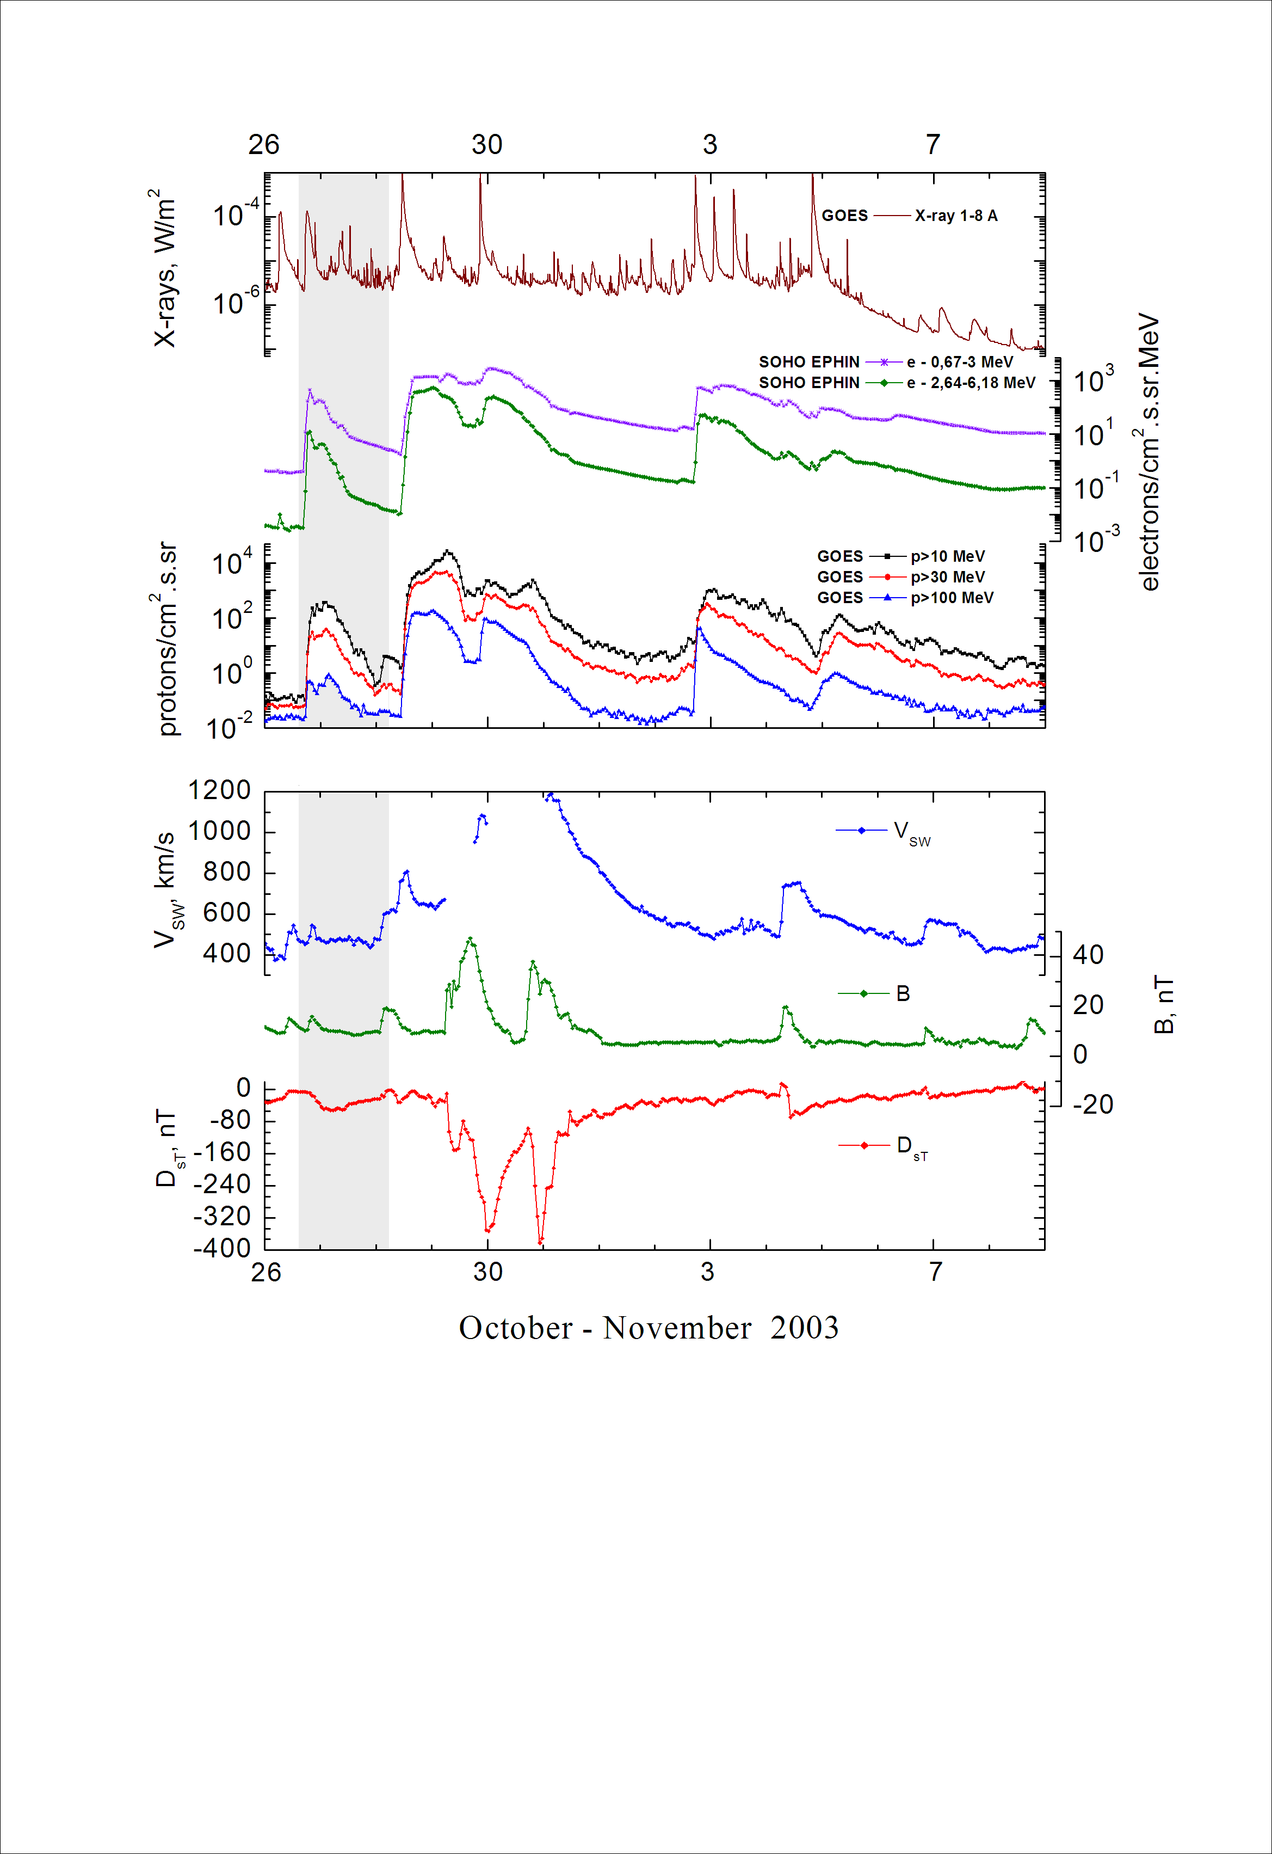
Integral time-of-maximum proton spectrum
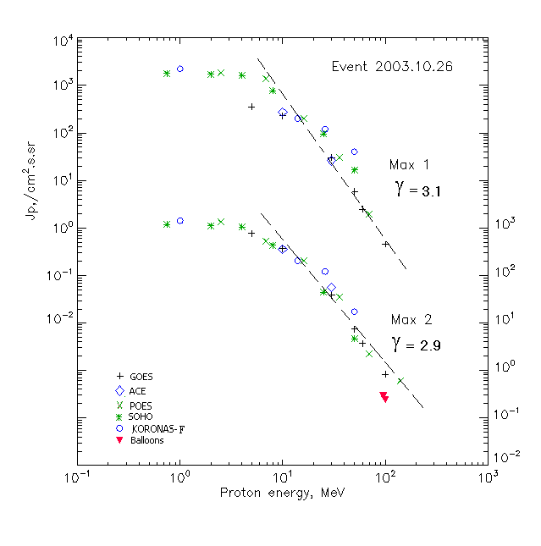

Integral fluxes of protons for the event of 2003.10.26

S/c, instruments | Eр, MeV | To | Tmax | Jmax,  (cm².s.sr)⁻¹ | Dura-tion | Comments
GOES-10
EPS | >5 | 18^{h} | 20^{h}/27d02^{h} | 354/758 | 2d
EPS | >10 | 18^{h} | 20^{h}/27d02^{h} | 230/360 | 2d
EPS | >30 | 18^{h} | 20^{h}/27d02^{h} | 30.3/38 | 2d
EPS | >50 | 18^{h} | 20^{h}/27d02^{h} | 5.9/7.3 | 2d
EPS | >60 | 18^{h} | 19^{h}/27d02^{h} | 2.5/3.7 | 2d
EPS | >100 | 18^{h} | 19^{h}/27d02^{h} | 0.46/0.83 | 2d
POES-16
MEPED | >0.24 | - | - | - | -
MEPED | >0.8 | - | ⁻ | - | -
MEPED | >2.5 | - | 19^{h}/27d04^{h} | 1.8·10³/1.3·10³ | 2d
MEPED | >6.9 | - | 19^{h}/27d04^{h} | 1.4·10³/520 | 2d
MEPED | >16 | - | 19^{h}/27d04^{h} | 230/240 | 2d
MEPED | >36 | - | 19^{h}/27d04^{h} | 30/35 | 2d
MEPED | >70 | - | 19^{h}/27d04^{h} | 2/2.2 | 2d
MEPED | >140 | - | - /27d04^{h} | - /0.6 | 2d
CORONAS F
MKL | >1. | - | 23^{h}/27d05^{h} | 2.2·10³/1.4·10³ | 2d
MKL | >14 | - | 23^{h}/27d05^{h} | 240/220 | 2d
MKL | >26 | - | 22^{h}/27d05^{h} | 125/120 | 2d
MKL | >50 | - | 22^{h}/27d05^{h} | 40/17 | 2d
ACE
SIS | >10 | 17^{h} | 21^{h}/27d03^{h} | 273/352 | 2d
SIS | >30 | 17^{h} | 19^{h}/27d03^{h} | 26/55.5 | 2d
SOHO
EPHIN (INT) | >50 | 17^{h} | 18^{h}/27d03^{h} | 16.6/4.6 | 1.5d
BALLOONS
Mu | >96 |  | - /27d10^{h} | - /0.29
Mu | >100 |  | - /27d10^{h} | - /0.24

Differential fluxes of protons for the event of 2003.10.26

S/c,  instruments | ∆Е, MeV | To | Tmax | Jmax, (cm².s.sr.MeV)⁻¹ | Dura-tion | Comments
SOHO
LION | 0.75-2 | 20^{h} | 23^{h}/27d06^{h} | 38/42 | 2d
LION | 2-6 | 19^{h} | 23^{h}/27d05^{h} | 34/22.5 | 2d
EPHIN | 4-8 | 19^{h} | 22^{h}/27d06^{h} | 212/150 | 2d
EPHIN | 8-25 | 18^{h} | 22^{h}/27d05^{h} | 39.6/22.3 | 2d
EPHIN | 25-41 | 18^{h} | 18^{h}/27d03^{h} | 2.8/1.4 | 2d
EPHIN | 41-53 | - “ - | - “ - | - “ - | - “ -

References:
Kuwabara T., J.W. Bieber, J. Clem, et.al., 2006.
Веселовский И.С., И.Н. Мягкова, О.С. Яковчук, 2012.

