Event 2003.10.28 – (2003-301) – GLE-65

Particle event: To(Ep>10 MeV) – 28d12^{h}
Tmax₁(Ep>10 MeV) – 28d18^{h}, Jmax₁(Ep>10 MeV) – 4.6·10³ /cm².s.sr
Tmax₂(Ep>10 MeV) – 29d02^{h}, Jmax₂(Ep>10 MeV) – 1.2·10⁴ /cm².s.sr
Duration of the event – 1 day
Energy of the SCR and 0.1 GCR fluxes balance – Eb(max₁) = 3340 MeV
– Eb(max₂) = 1025 MeV
Sources ● solar flare 28d09^{h}51^{m}, X17.2/4B, S16E08, АR10486
Main X-ray burst 1-8 Ǻ: onset – 28d09^{h}51^{m}, max – 28d11^{h}10^{m}, Ф = 1.8 J/m²
CME: 28d11^{h}30^{m}; V=2459 km/s; ∆φ = 360º; dA = 015º
▲SC 29d06^{h}11^{m}

Particle fluxes and associated phenomena
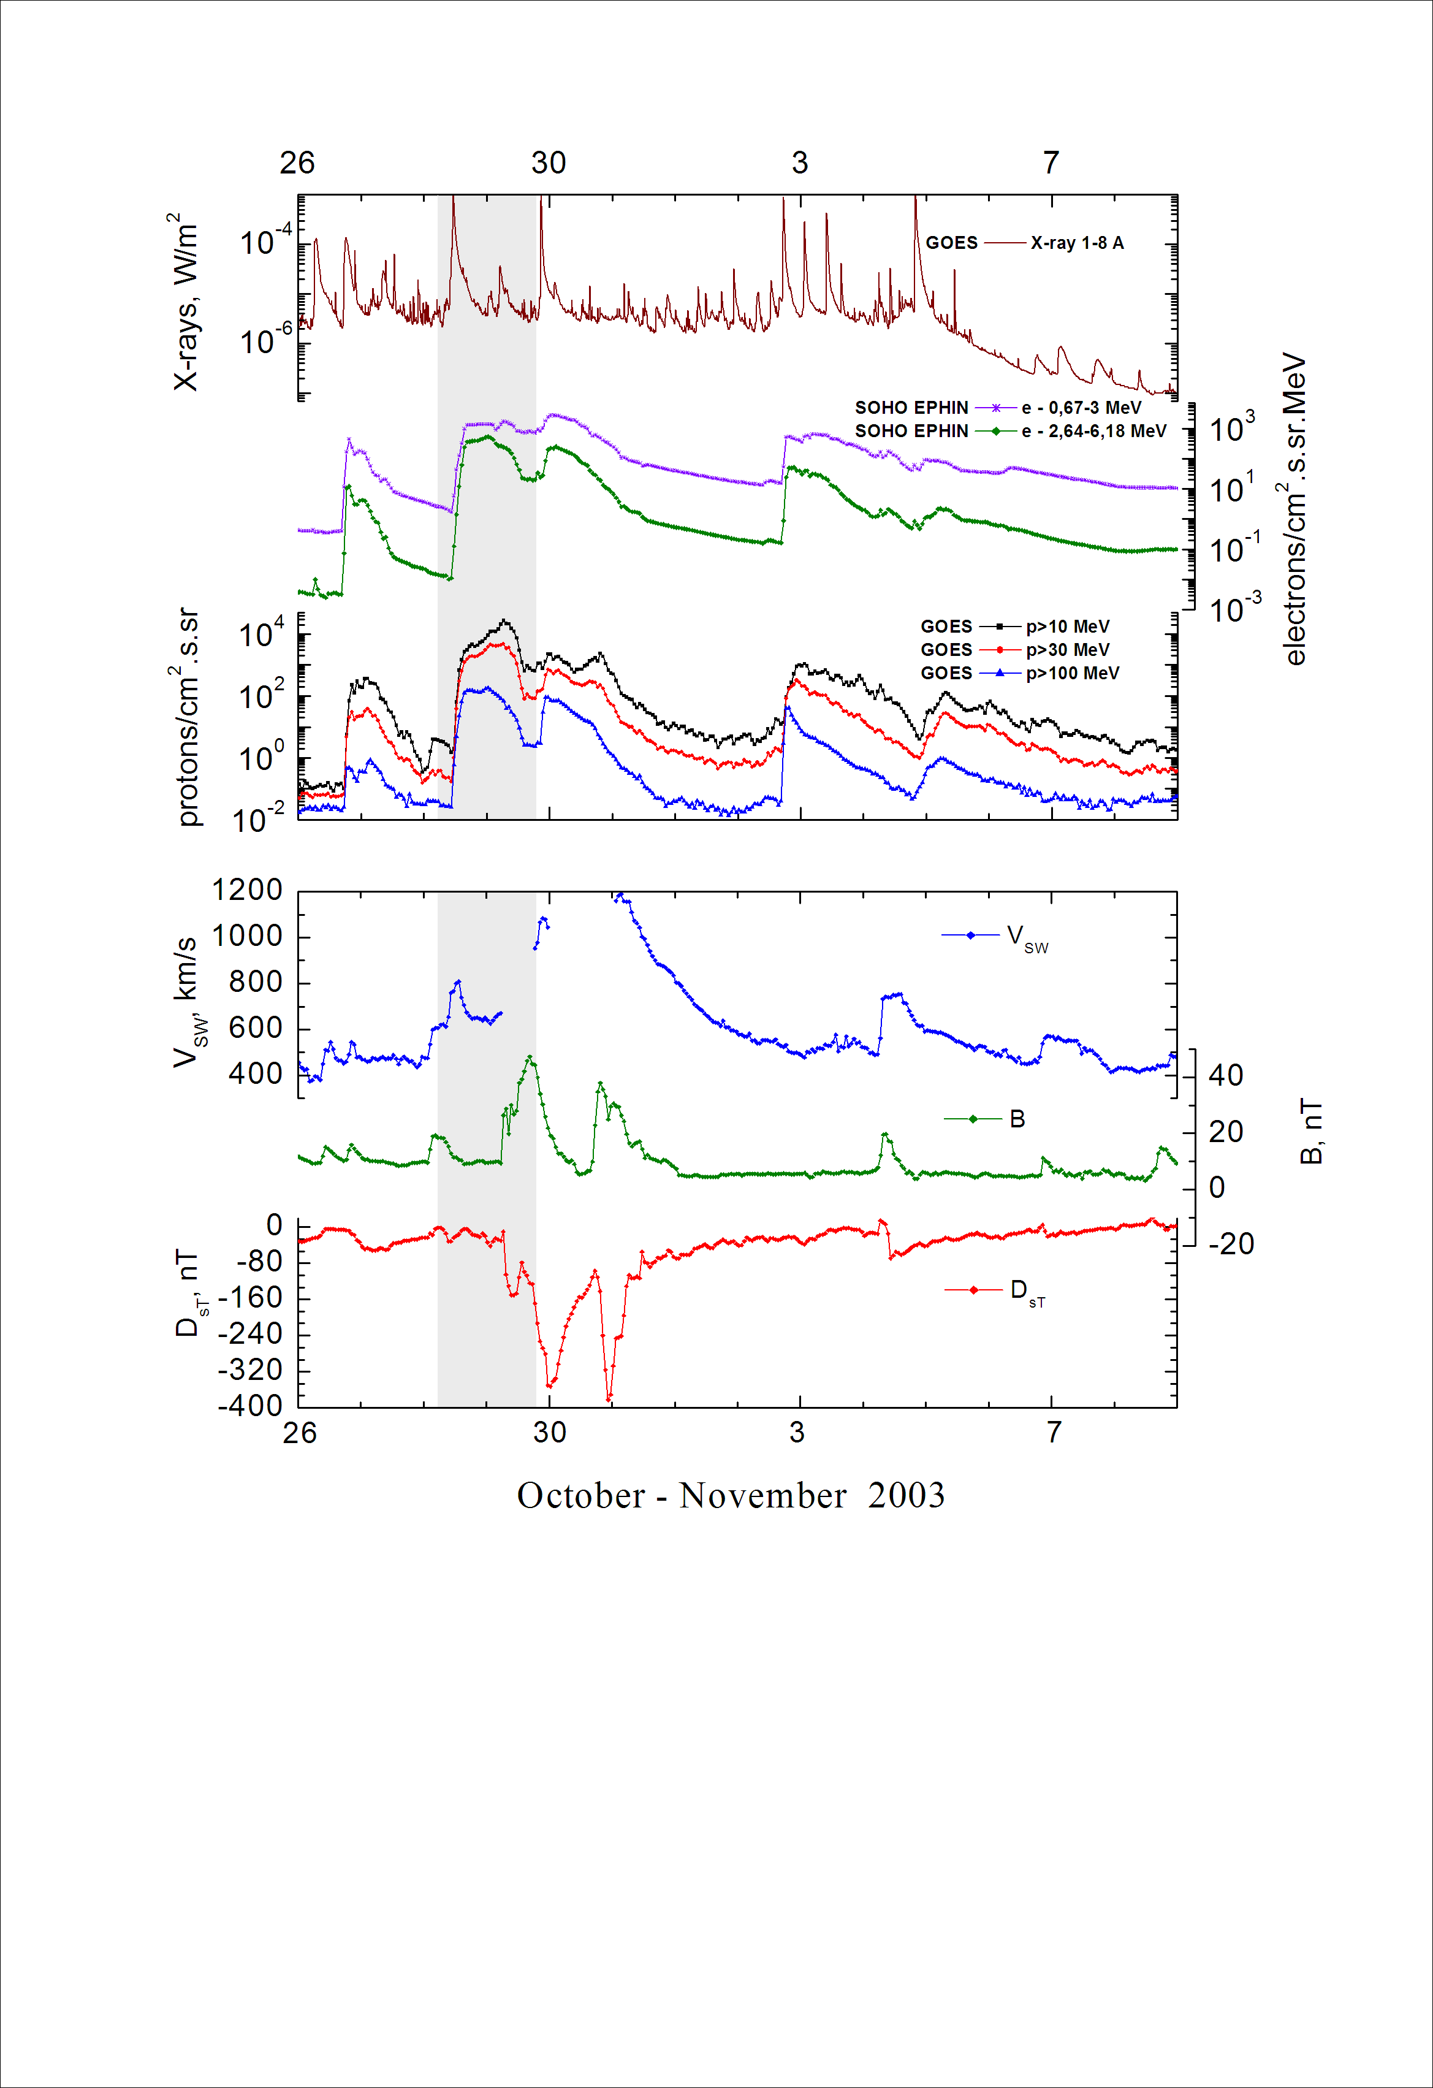
Integral time-of-maximum proton spectrum
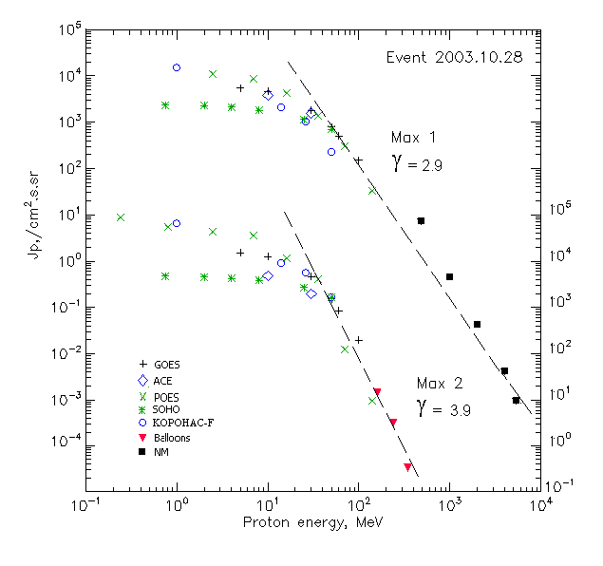

Integral fluxes of protons for the event of 2003.10.28

S/c,  instruments | Eр, MeV | To | Tmax | Jmax,  (cm².s.sr)⁻¹ | Dura-tion | Comments
GOES-10
EPS | >5 | 12^{h} | 18^{h}/29d02^{h} | 5.5·10³/1.4·10⁴ | 1d
EPS | >10 | 12^{h} | 18^{h}/29d02^{h} | 4.6·10³/1.2·10⁴ | 1d
EPS | >30 | 12^{h} | 17^{h}/29d02^{h} | 1.8·10³/4.4·10³ | 1d
EPS | >50 | 12^{h} | 17^{h}/29d01^{h} | 790/1.45·10³ | 1d
EPS | >60 | 12^{h} | 17^{h}/29d01^{h} | 510/820 | 1d
EPS | >100 | 12^{h} | 16^{h}/29d01^{h} | 150/185 | 1d
POES-16
MEPED | >0.24 | - | ⁻ /29d07^{h} | - /8.1·10⁴ | 1d
MEPED | >0.8 | - | - /29d07^{h} | - /5.2·10⁴ | 1d
MEPED | >2.5 | - | 16^{h}/29d07^{h} | 1.1·10⁴/4.1·10⁴ | 1d
MEPED | >6.9 | - | 16^{h}/29d07^{h} | 8.7·10³/3.4·10⁴ | 1d
MEPED | >16 | - | 16^{h}/29d07^{h} | 4.2·10³/1.1·10⁴ | 1d
MEPED | >36 | - | 16^{h}/29d07^{h} | 1.4·10³/3.8·10³ | 1d
MEPED | >70 | - | 16^{h}/29d07^{h} | 310/ 120 | 1d
MEPED | >140 | - | 16^{h}/29d07^{h} | 33/ 9 | 1d
CORONAS F
MKL | >1. | - | 15^{h}/29d07^{h} | 1.5·10⁴/6.2·10⁴ | 1d
MKL | >14 | - | 15^{h}/29d07^{h} | 2.1·10³/8.6·10³ | 1d
MKL | >26 | - | 15^{h}/29d07^{h} | 1.0·10³/5.3·10³ | 1d
MKL | >50 | - | 15^{h}/29d07^{h} | 230/1.6·10³ | 1d
ACE
SIS | >10 | 12^{h} | 17^{h}/29d02^{h} | 3.9·10³/4.9·10³ | 1d
SIS | >30 | 12^{h} | 17^{h}/29d01^{h} | 1.6·10³/1.9·10³ | 1d
SOHO
EPHIN (INT) | >50 | 12^{h} | 17^{h}/29d02^{h} | 704/1580 | 1d
BALLOONS
Mu | >160 | - | - /23 ^{h} ÷29d01^{h} | - /13.4 | -
Mu | >242 | - | - /23 ^{h} ÷29d01^{h} | - /3 | -
Mu | >348 | - | - /23 ^{h} ÷29d01^{h} | - /0.32 | -
NM
Network | >433 | - | 11 ^{h}55^{m}/ - | 7.6/ - | -
Network | >1000 | - | 11 ^{h}55^{m}/ - | 0.44/ - | -
Network | >2000 | - | 11 ^{h}55^{m}/ - | 0.042/ - | -
Network | >3700 | - | 11 ^{h}55^{m}/ - | 0.005/ - | -
Network | >5800 | - | 11 ^{h}55^{m}/ - | 0.0009/ - | -

Differential fluxes of protons for the event of 2003.10.28

S/c,  instruments | ∆Е, MeV | To | Tmax | Jmax, (cm².s.sr.MeV)⁻¹ | Dura-tion | Comments
SOHO
LION | 0.75-2 | 14^{h} | 17^{h}/29d02^{h} | 50/150 | 1.5d
LION | 2-6 | 14^{h} | 17^{h}/29d01^{h} | 48/102 | 1.5d
EPHIN | 4-8 | 13^{h} | 17^{h}/29d01^{h} | 77/87 | 1.5d
EPHIN | 8-25 | 12^{h} | 17^{h}/29d01^{h} | 39/64 | 1.5d
EPHIN | 25-41 | 12^{h} | 17^{h}/29d02^{h} | 16/36 | 1d
EPHIN | 41-53 | - “ - | - “ - | - “ - | - “ -

References:
Struminsky A., 2005.
Bieber J.W., Clem J., Evenson P., et.al., 2005.
Miroshnichenko L.I., Klein K.-L., Trottet G., et.al., 2005.
Plainaki C., Belov A., Eroshenko E., et.al., 2003.
Kuwabara T., Bieber J.W., Clem J., et.al., 2006.
Perez-Peraza J., Gallegos-Cruz A., Vashenyuk E.V., et.al., 2006.
Dmitriev A.V., Yeh H.-C., Chao J.-K., et.al., 2006.
Nonaka T., Hayashi Y., Ito N., et.al., 2006.
Miroshnichenko L.I. and Perez-Peraza J., 2008.
Lario D., Decker R.B., and Aran A., 2008.
Struminsky A., Heber B., Gomez-Herrero R., Klassen A., 2008.
Lario D, Aran A, Decker R.B., 2009.
Troitskaia E.V., Arkhangelskaja I.V., Miroshnichenko L.I., et.al., 2009.
Perez-Peraza J., Gallegos-Cruz A., Vashenyuk E.V., 2009.
Кичигин Г.Н., Мирошниченко Л.И., Сидоров В.И., et.al., 2012.
Мирошниченко Л.И., Перес-Пераса Х.А., Веласко-Эррера В.М., et.al., 2012.
Miroshnichenko L.I. and Gan W.Q., 2012.
Maurchev E.A., Balabin Yu.V., Vashenyuk E.V., et.al., 2013.
Velinov P., Mishev A., 2013.

