Event 2003.10.29 – (2003-302) – GLE-66

Particle event: To(Ep>10 MeV) – 29d22^{h}
Tmax(Ep>10 MeV) – 29d23^{h}, Jmax(Ep>10 MeV) – 2230 /cm².s.sr
Duration of the event – 2 days
Energy of the SCR and 0.1 GCR fluxes balance – Eb = 810 MeV

Sources: ● solar flare 29d20^{h}37^{m}, X10.0/2B, S15W02, АR10486
Ø solar flare 30d01^{h}53^{m}, 1F/M1.6, N08W22, АR10488
Main X-ray burst 1-8 Ǻ: onset – 29d20^{h}37^{m}, max – 29d20^{h}49^{m}, Ф = 0.87 J/m²
CME: 29d20^{h}54^{m}; V = 2459 km/s ; Δφ = 360º; dA = 015º
▲SC 29d06^{h}11^{m}

Particle fluxes and associated phenomena
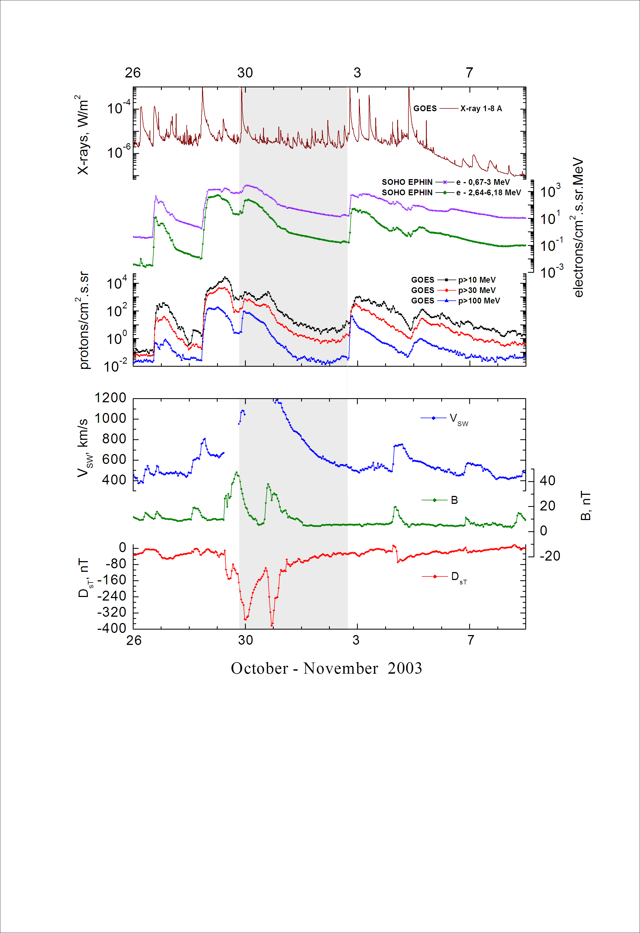

Integral time-of-maximum proton spectrum
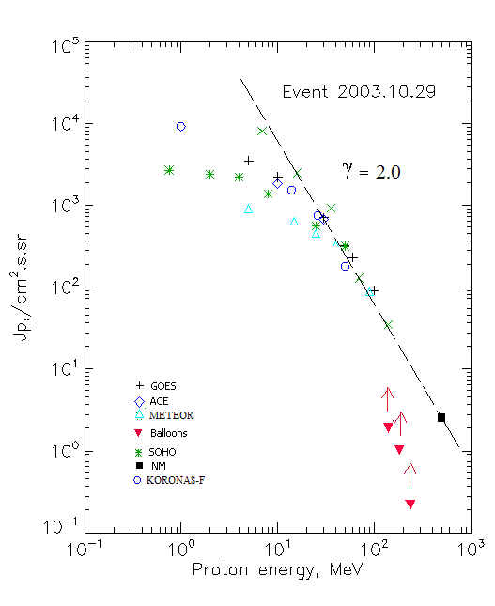

Integral fluxes of protons for the event of 2003.10.29

S/c, instruments | Eр, MeV | To | Tmax | Jmax,  (cm².s.sr)⁻¹ | Dura-tion | Comments
GOES-10
EPS | >5 | 22^{h} | 30d01^{h} | 3520 | 2.5d
EPS | >10 | 22^{h} | 23^{h} | 2230 | 2.5d
EPS | >30 | 21^{h} | 23^{h} | 707 | 2d
EPS | >50 | 21^{h} | 23^{h} | 320 | 2d
EPS | >60 | 21^{h} | 23^{h} | 230 | 2d
EPS | >100 | 21^{h} | 23^{h} | 91 | 2d
METEOR
CBM | >5 | 20 ^{h} | 30d01 ^{h} | 920 | 2.5d
CBM | >10 | 20 ^{h} | 30d00 ^{h} | 640 | 2.5d
CBM | >25 | 20 ^{h} | 23 ^{h} | 460 | 2.5d
CBM | >40 | 20 ^{h} | 23 ^{h} | 330 | 2d
BP | >90 | 20 ^{h} | 23 ^{h} | 90 | 2d
ChD | >600 | - | - | - | -
POES-16
MEPED | >0.24 | - | ⁻ | - | - | .
MEPED | >0.8 | - | ⁻ | - | -
MEPED | >2.5 | - | ⁻ | - | -
MEPED | >6.9 | - | 23 ^{h} | 8120 | 2.5d
MEPED | >16 | - | 23 ^{h} | 2520 | 2.5d
MEPED | >36 | - | 23 ^{h} | 930 | 2.5d
MEPED | >70 | - | 23 ^{h} | 130 | 2d
MEPED | >140 | - | 23 ^{h} | 35 | 2d
CORONAS F
MKL | >1. | - | 24 ^{h} | 9240 | 2.5d
MKL | >14 | - | 24 ^{h} | 1550 | 2d
MKL | >26 | - | 24 ^{h} | 750 | 2d
MKL | >50 | - | 24 ^{h} | 180 | 2d
ACE
SIS | >10 | 22^{h} | 23^{h} | 1840 | 2d
SIS | >30 | 22^{h} | 23^{h} | 680 | 2d
SOHO
EPHIN (INT) | >50 | 21^{h} | 30d01^{h} | 320 | 1.5d
BALLOONS
Mu | >141 | - | 20^{h}30^{m} | 1.9 | - | Before
Mu | >183 | - | 20^{h}30^{m} | 1 | - | maximum
Mu | >238 | - | 20^{h}30^{m} | 0.22 | -
NM
Network | >500 | - | 21^{h}30^{m} | 2.5 | -

Differential fluxes of protons for the event of 2003.10.29

S/c,  instruments | ∆Е, MeV | To | Tmax | Jmax, (cm².s.sr.MeV)⁻¹ | Dura-tion | Comments
SOHO
LION | 0.75-2 | 22^{h} | 30d00^{h} | 220 | 2d
LION | 2-6 | 22^{h} | 30d00^{h} | 70 | 2d
EPHIN | 4-8 | 22^{h} | 30d00^{h} | 210 | 2d
EPHIN | 8-25 | 22^{h} | 30d00^{h} | 48 | 2d
EPHIN | 25-41 | 22^{h} | 30d00^{h} | 8.7 | 2d
EPHIN | 41-53 | - “ - | - “ - | - “ - | - “ -

References;
Kuwabara T., Munakata K., Yasue S, et.al., 2004.
Dmitriev A.V., Yeh H.-C., Chao J.-K., et.al., 2006.
Kuwabara T., Bieber J.W., Clem J., et.al., 2006.
Miroshnichenko L.I. and Perez-Peraza J., 2008.
Lario D., Aran A., Decker R.B., 2009.
Веселовский И.С., Мягкова И.Н., Яковчук О.С., 2012
Lario D., Decker R.B. and Aran A., 2008.

