Event 2005.01.16 – (2005-016)

Particle event: To(Ep>10MeV) – 16d00^{h}
Tmax(Ep>10MeV) – 16d18^{h}, Jmax (Ep>10MeV) – 330 /cm².s.sr
Duration of the event – 1 day
Energy of the SCR and 0.1 GCR fluxes balance – Eb = 330 MeV

Sources: ● solar flare 15d22^{h}25^{m}, X2.6/3B, N14W08, АR10720
Main X-ray burst 1-8 Ǻ: onset – 15d22^{h}25^{m}, max – 15d23^{h}02^{m}, Ф = 0.63 J/m²
CME: 15d23^{h}06^{m}, V = 2861 km/s, Δφ = 360º, dA = 323˚;

Particle fluxes and associated phenomena
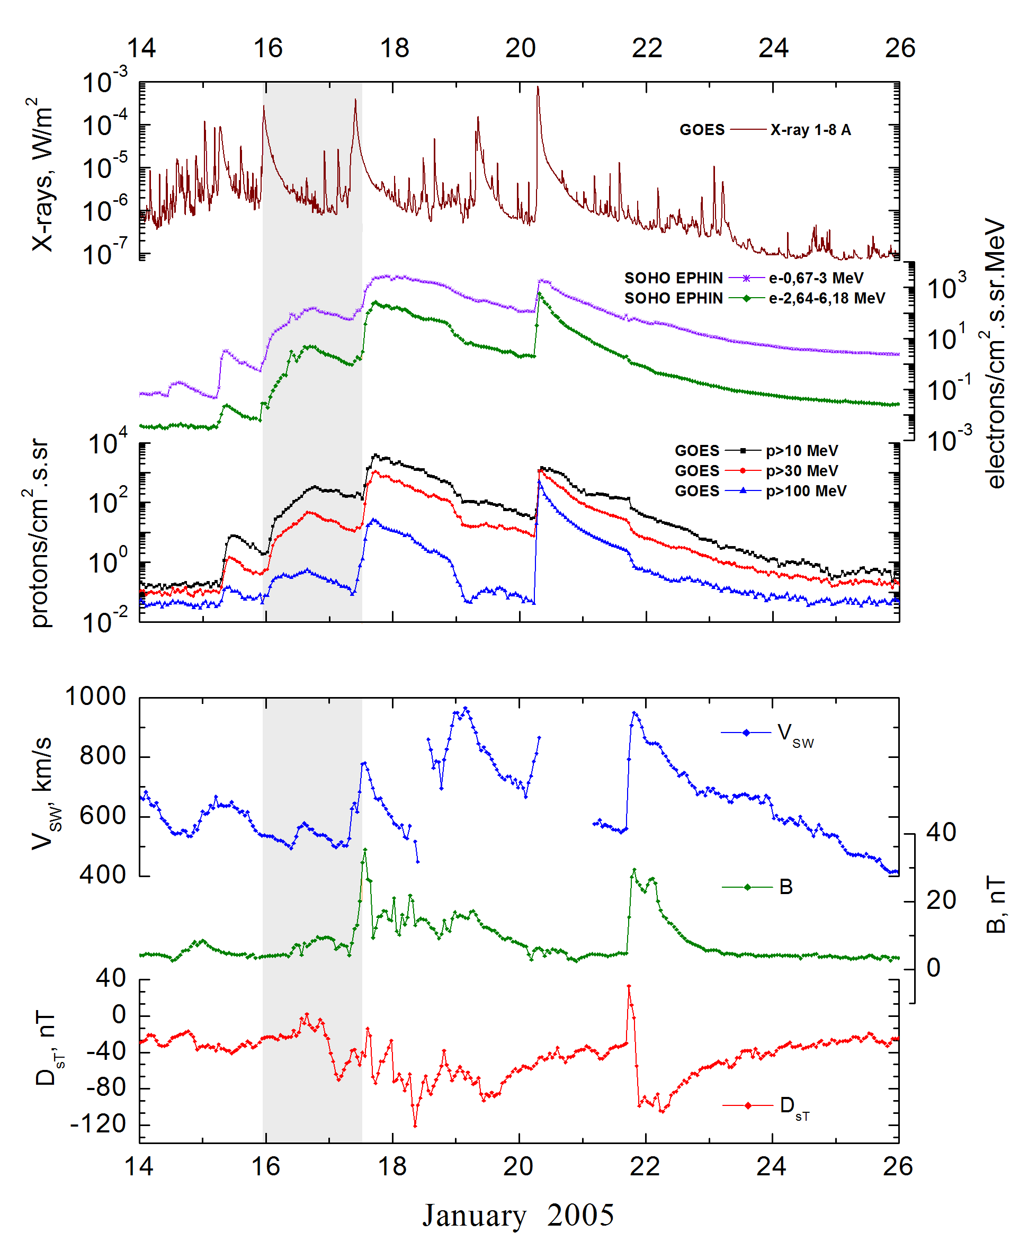

Integral time-of-maximum proton spectrum
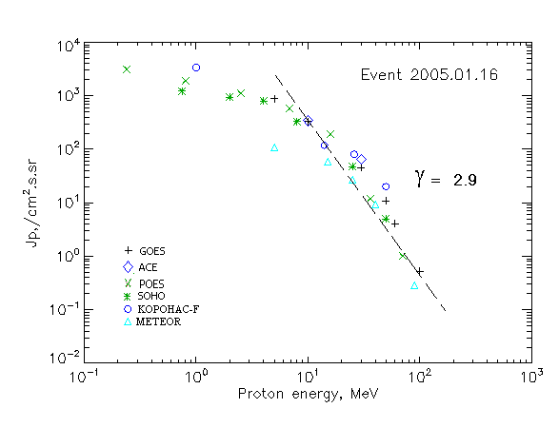

ntegral fluxes of protons for the event of 2005.01.16

S/c,  instruments | Eр, MeV | To | Tmax | Jmax,  (cm².s.sr)⁻¹ | Dura-tion | Comments
GOES-10
EPS | >5 | 00^{h} | 18^{h} | 890 | 1.5d
EPS | >10 | 00^{h} | 18^{h} | 330 | 1.5d
EPS | >30 | 00^{h} | 15^{h} | 45.5 | 1.5d
EPS | >50 | 00^{h} | 15^{h} | 10.8 | 1.5d
EPS | >60 | 00^{h} | 15^{h} | 4.1 | 1.5d
EPS | >100 | 00^{h} | 15^{h} | 0.52 | 1.5d
METEOR
CBM | >5 | 00 ^{h} | 16 ^{h} | 107 | 1.5d
CBM | >15 | 00 ^{h} | 16 ^{h} | 59 | 1.5d
CBM | >25 | 00 ^{h} | 16 ^{h} | 27 | 1.5d
CBM | >40 | 00 ^{h} | 16 ^{h} | 9,4 | 1.5d
BP | >90 | 00 ^{h} | 16 ^{h} | 0,29 | 1.5d
ChD | >600 | - | - | - | -
POES-16
MEPED | >0.24 | 00 ^{h} | 18 ^{h} | 3150 | 1.5d
MEPED | >0.8 | 00 ^{h} | 18 ^{h} | 3000 | 1.5d
MEPED | >2.5 | 00 ^{h} | 16 ^{h} | 1100 | 1.5d
MEPED | >6.9 | 00 ^{h} | 16 ^{h} | 580 | 1.5d
MEPED | >16 | 00 ^{h} | 16 ^{h} | 190 | 1.5d
MEPED | >36 | 00 ^{h} | 16 ^{h} | 12 | 1.5d
MEPED | >70 | 00 ^{h} | 13 ^{h} | 1 | 1.5d
MEPED | >140 | 00 ^{h} | ⁻ | - | -
CORONAS F
MKL | >1 | - | 18^{h} | 3400 | 1.5d
MKL | >14 | - | 17^{h} | 120 | 1.5d
MKL | >26 | - | 17^{h} | 80 | 1.5d
MKL | >50 | - | 17^{h} | 20 | 1.5d
ACE
SIS | >10 | 00^{h} | 17^{h} | 342 | 1.5d
SIS | >30 | 15d 23^{h} | 14^{h} | 65 | 1.5d
SOHO
EPHIN (INT) | >50 | 07^{h} | 14^{h} | 5.0 | 1.5d

Differential fluxes of protons for the event of 2005.01.16

S/c, instruments | ∆Е, MeV | To | Tmax | Jmax, (cm².s.sr.MeV)⁻¹ | Dura-tion | Comments
SOHO
LION | 0.75-2 | 03^{h} | 20 ^{h} | 231 | 1.5d
LION | 2-6 | 03^{h} | 20 ^{h} | 48 | 1.5d
EPHIN | 4-8 | 02^{h} | 14^{h} | 116 | 1.5d
EPHIN | 8-25 | 01^{h} | 14^{h} | 16.7 | 1.5d
EPHIN | 25-41 | 01^{h} | 14^{h} | 1.5 | 1.5d
EPHIN | 41-53 | - “ - | - “ - | - “ - | - “ -

References:
No information on publications, excepting for:
http://www.swpc.noaa.gov/ftpdir/indices/SPE.txt

