Event 2005.08.22a – (2005-234a)

Particle event: To(Ep>10MeV) – 22d19^{h}
Tmax₁(Ep>10MeV) – 23d02^{h}, Jmax₁(Ep>10MeV) – 280 /cm².s.sr
Tmax₂(Ep>10MeV) – 23d10^{h}, Jmax₂(Ep>10MeV) – 290 /cm².s.sr
Duration of the event – 3 days
Energy of the SCR and 0.1 GCR fluxes balance – Eb(max₁) = 330 MeV
– Eb(max₂) = 290 MeV

Sources: ● solar flare 22d16^{h}52^{m}, M5.6/1N, S12W60, АR10798
Ø solar flare 23d14^{h}19^{m}, M2.7/SF, S07W16, АR10798
Main X-ray burst 1-8 Ǻ: onset – 22d16^{h}52^{m}, max – 22d17^{h}27^{m}, Ф = 0.17 J/m²
CME: 22d17^{h}30^{m}, V=2378 km/s, Δφ = 360º, dA= 220º;
▲SC 24d06^{h}13^{m}

Particle fluxes and associated phenomena
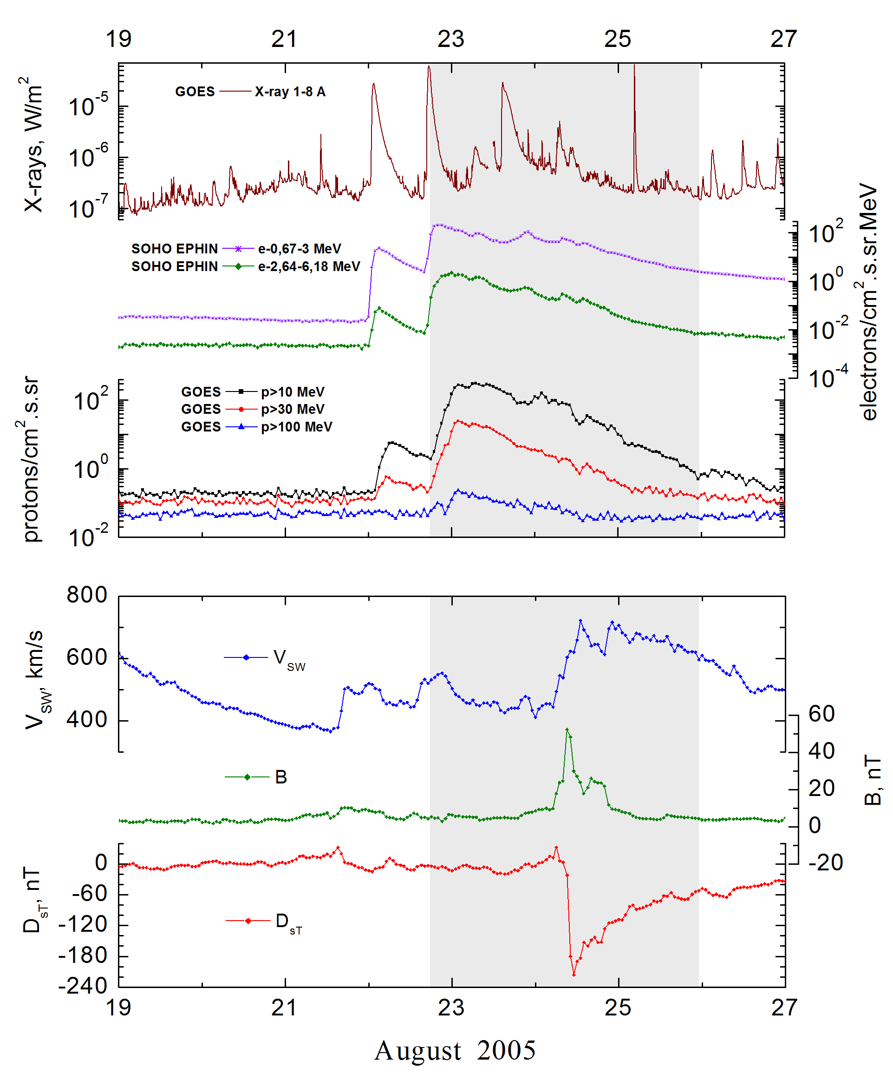
Integral time-of-maximum proton spectrum
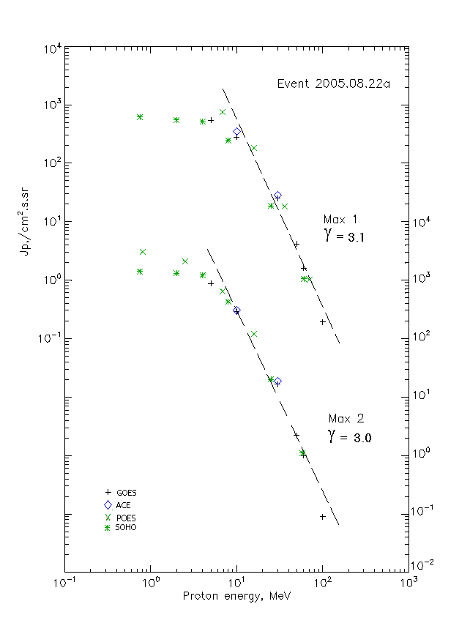

Integral fluxes of protons for the event of 2005.08.22а

S/c, instruments | Eр, MeV | To | Tmax | Jmax,  (cm².s.sr)⁻¹ | Dura-tion | Comments
GOES-10
EPS | >5 | 19^{h} | 23d02 ^{h}/23d10 ^{h} | 540/880 | 3d
EPS | >10 | 19^{h} | 23d02 ^{h}/23d10 ^{h} | 280/290 | 3d
EPS | >30 | 19^{h} | 23d02 ^{h}/23d10 ^{h} | 24.9/16.7 | 2d
EPS | >50 | 19^{h} | 23d02 ^{h}/23d10 ^{h} | 4.1/2.2 | 2d
EPS | >60 | 19^{h} | 23d02 ^{h}/23d10 ^{h} | 1.6/1 | 2d
EPS | >100 | 18^{h} | 23d02 ^{h}/23d10 ^{h} | 0.19/0.09 | 1d
POES-16
MEPED | >0.24 | - | - | - | -
MEPED | >0.8 | - | - /23d10 ^{h} | - /3120 | 3d
MEPED | >2.5 | - | - /23d10 ^{h} | - /2140 | 3d
MEPED | >6.9 | - | 23d02 ^{h}/23d10 ^{h} | 760/650 | 3d
MEPED | >16 | - | 23d02 ^{h}/23d10 ^{h} | 180/120 | 3d
MEPED | >36 | - | 23d02 ^{h}/ - | 18.1/ - | 2d
MEPED | >70 | - | 23d02 ^{h}/ - | 1/ - | 2d
MEPED | >140 | - | - | - | -
ACE
SIS | >10 | 19^{h} | 23d02 ^{h}/23d10 ^{h} | 350/308 | 4 d
SIS | >30 | 19^{h} | 23d02 ^{h}/23d10 ^{h} | 28.5/19 | 4 d
SOHO
EPHIN (INT) | >50 | 19^{h} | 23d01 ^{h}/23d09 ^{h} | 1.05/1 | 2d

Differential fluxes of protons for the event of 2005.08.22а

S/c, instruments | ∆Е, MeV | To | Tmax | Jmax, (cm².s.sr.MeV)⁻¹ | Dura-tion | Comments
SOHO
LION | 0.75-2 | 19^{h} | 23d01 ^{h}/23d09 ^{h} | 51/75.4 | 3d
LION | 2-6 | 19^{h} | 23d01 ^{h}/23d09 ^{h} | 13.3/33.7 | 3d
EPHIN | 4-8 | 19^{h} | 23d01 ^{h}/23d09 ^{h} | 66.8/200 | 3d
EPHIN | 8-25 | 19^{h} | 23d01 ^{h}/23d09 ^{h} | 13.3/24 | 3d
EPHIN | 25-41 | 19^{h} | 23d01 ^{h}/23d09 ^{h} | 0.62/0.68 | 3d

References:
No information on publications, excepting for:
http://www.swpc.noaa.gov/ftpdir/indices/SPE.txt

