Event 2006.12.06 – (2006-340)

Particle event: To(Ep>10MeV) – 06d10^{h}
Tmax(Ep>10MeV) – 07d22^{h}, Jmax(Ep>10MeV) – 1860 /cm².s.sr
Duration of the event – 5 days
Energy of the SCR and 0.1 GCR fluxes balance – Eb = 850 MeV

Sources: ● solar flare 06d18^{h}24^{m}, 3B/X6.5, S06E63 АR10930
Main x-ray burst 1–8 Ǻ: onset – 06d18^{h}29^{m}, max – 06d18^{h}47^{m}, Ф = 0.480 J/m²
CME: 06d20^{h}12^{m}, V = ….. km/s, Δφ = 360º, dA = 135˚.
▲SC 08d04^{h}35^{m}

Particle fluxes and associated phenomena
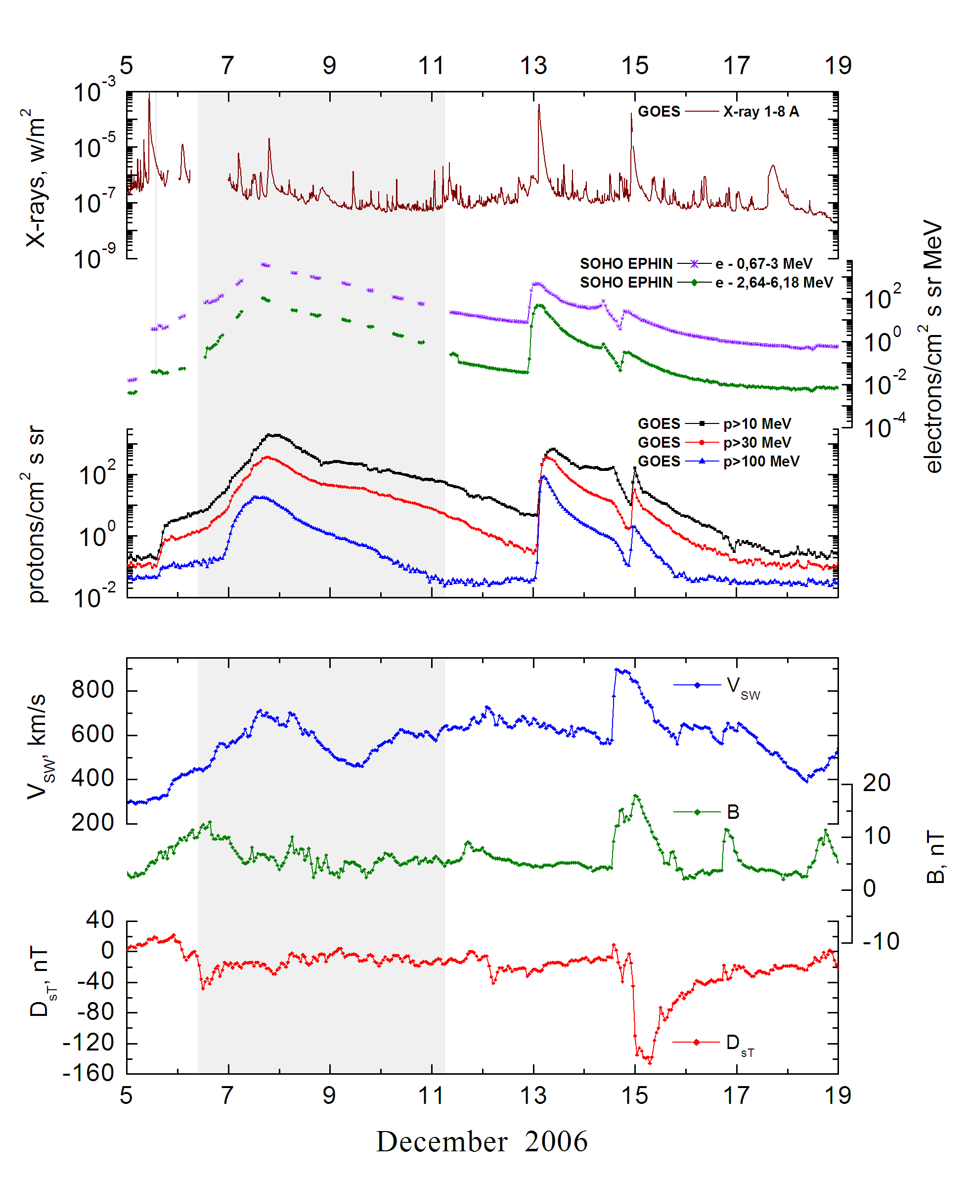

Integral time-of-maximum proton spectrum
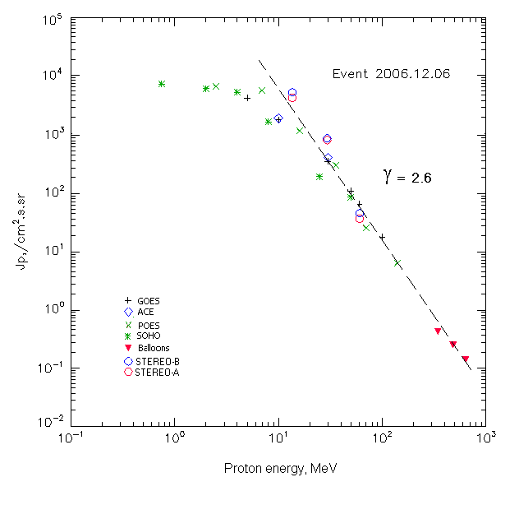

Integral fluxes of protons for the event of 2006.12.06

S/c, instruments | Eр, MeV | To | Tmax | Jmax,  (cm².s.sr)⁻¹ | Dura-tion | Comments
GOES-10
EPS | >5 | 10^{h} | 7d23^{h} | 4460 | 6d
EPS | >10 | 10^{h} | 7d22^{h} | 1860 | 6d
EPS | >30 | 10^{h} | 7d18^{h} | 360 | 6d
EPS | >50 | 10^{h} | 7d16^{h} | 112 | 5d
EPS | >60 | 10^{h} | 7d16^{h} | 66 | 5d
EPS | >100 | 10^{h} | 7d12^{h} | 18 | 4d
POES-16
MEPED | >0.24 | - | - | - | -
MEPED | >0.8 | - | - | - | -
MEPED | >2.5 | - | 7d23^{h} | 7220 | -
MEPED | >6.9 | - | 7d23^{h} | 6130 | -
MEPED | >16 | - | 7d20^{h} | 1230 | -
MEPED | >36 | - | 7d18^{h} | 310 | -
MEPED | >70 | - | 7d14^{h} | 26 | -
MEPED | >140 | - | 7d13^{h} | 6.5 | -
ACE
SIS | >10 | 10^{h} | 7d18^{h} | 1990 | 6d
SIS | >30 | 10^{h} | 7d16^{h} | 420 | 6d
SOHO
EPHIN (INT) | >50 | 10^{h} | 7d20^{h} | 86.8 | 5d
BALLONS
Mi | >345 |  | 8d(09^{h}37^{m}-09^{h}57^{m}) | 0.42 |  | 12 hours after
Mi | >483 |  | 8d(09^{h}37^{m}-09^{h}57^{m}) | 0.25 |  | maximum
Mi | >642 |  | 8d(09^{h}37^{m}-09^{h}57^{m}) | 0.14

Differential fluxes of protons for the event of 2006.12.06

S/c, instruments | ∆Е, MeV | To | Tmax | Jmax, (cm².s.sr.MeV)⁻¹ | Dura-tion | Comments
SOHO
LION | 0.75-2 | - | 7d23^{h} | 980 | 6d
LION | 2-6 | - | 7d23^{h} | 310 | 6d
EPHIN | 4-8 | - | 7d22^{h} | 950 | 6d
EPHIN | 8-25 | 10^{h} | 7d22^{h} | 90 | 6d
EPHIN | 25-41 | 10^{h} | 7d21^{h} | 4 | 6d
STEREO – A
HET | 13.6-29.5 | 12^{h} | 8d00^{h} | 267 | 6.5d
HET | 29.5-60 | 12^{h} | 8d00^{h} | 27.5 | 6.5d
HET | 60-100 | 12^{h} | 8d00^{h} | 0.7 | 6.5d
STEREO - B
HET | 13.6-29.5 | 12^{h} | 8d00^{h} | 342 | 6.5d
HET | 29.5-60 | 12^{h} | 8d00^{h} | 29.3 | 6.5d
HET | 60-100 | 12^{h} | 8d00^{h} | 0.83 | 6.5d

References:
Struminsky A. and Zimovets I., 2008.
Cohen C.M.S., Mason G.M., Mewaldt R.A.et al., 2009.
Damiani A., Storini M., Santee M., et.al.,2009.
Data from November 2004 to December 2006, in total 13 events, including 6 and 13 December 2006).
Веселовский И.С., Мягкова И.Н., Яковчук О.С, 2012.

