Event 1997.11.06 – (1997-310)

Particle event: To(Ep>10 MeV) – 06d13^{h}
Tmax(Ep>10 MeV) – 7d02^{h}, Jmax(Ep>10 MeV) – 430 /cm².s.sr
Duration of the event – 7 days
Energy of the SCR and 0.1 GCR fluxes balance – Eb = 2900 MeV

Sources: ● solar flare <06d11^{h}22^{m}, 2B/X9.4, S18W63, АR8100
Main burst X-ray 1-8 Ǻ: onset – 06d11^{h}49^{m}, max – 06d11^{h}55^{m}, Jmax = 0.036 J/m²
CME: 06d12^{h}10^{m}, V= 1556 km/s, Δφ = 360º, dA = 262º
▲SC 06d22^{h}52^{m}

Particle fluxes and associated phenomena
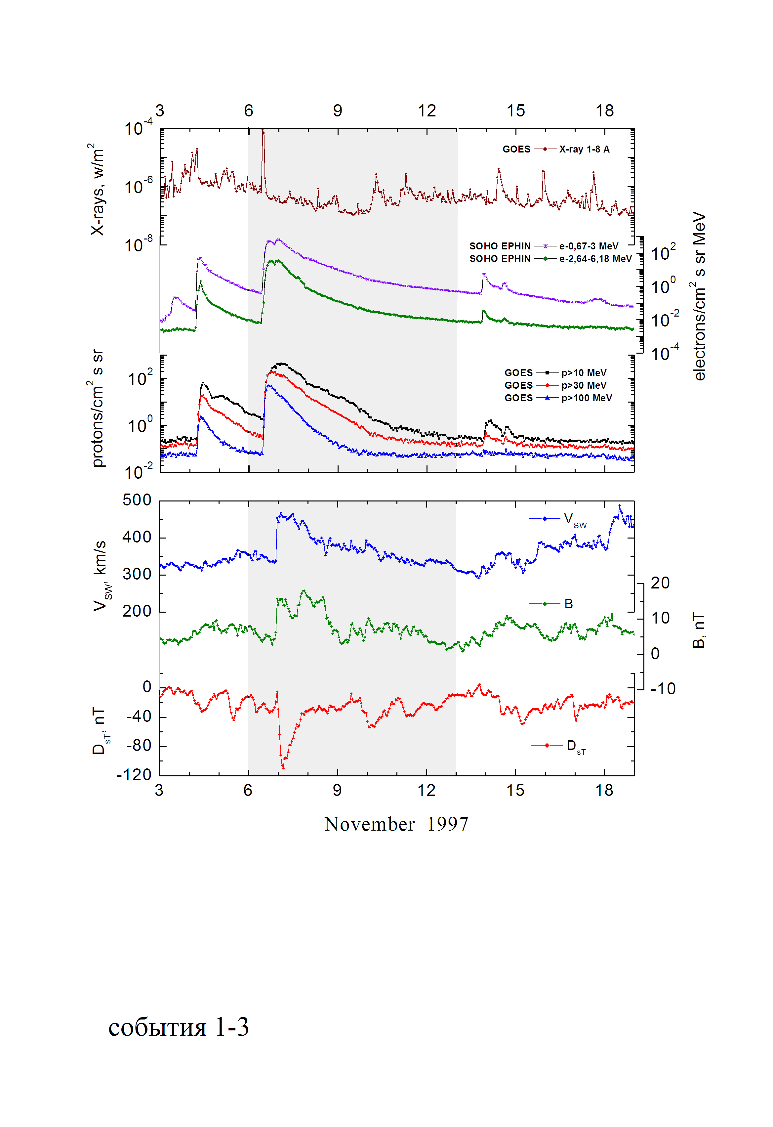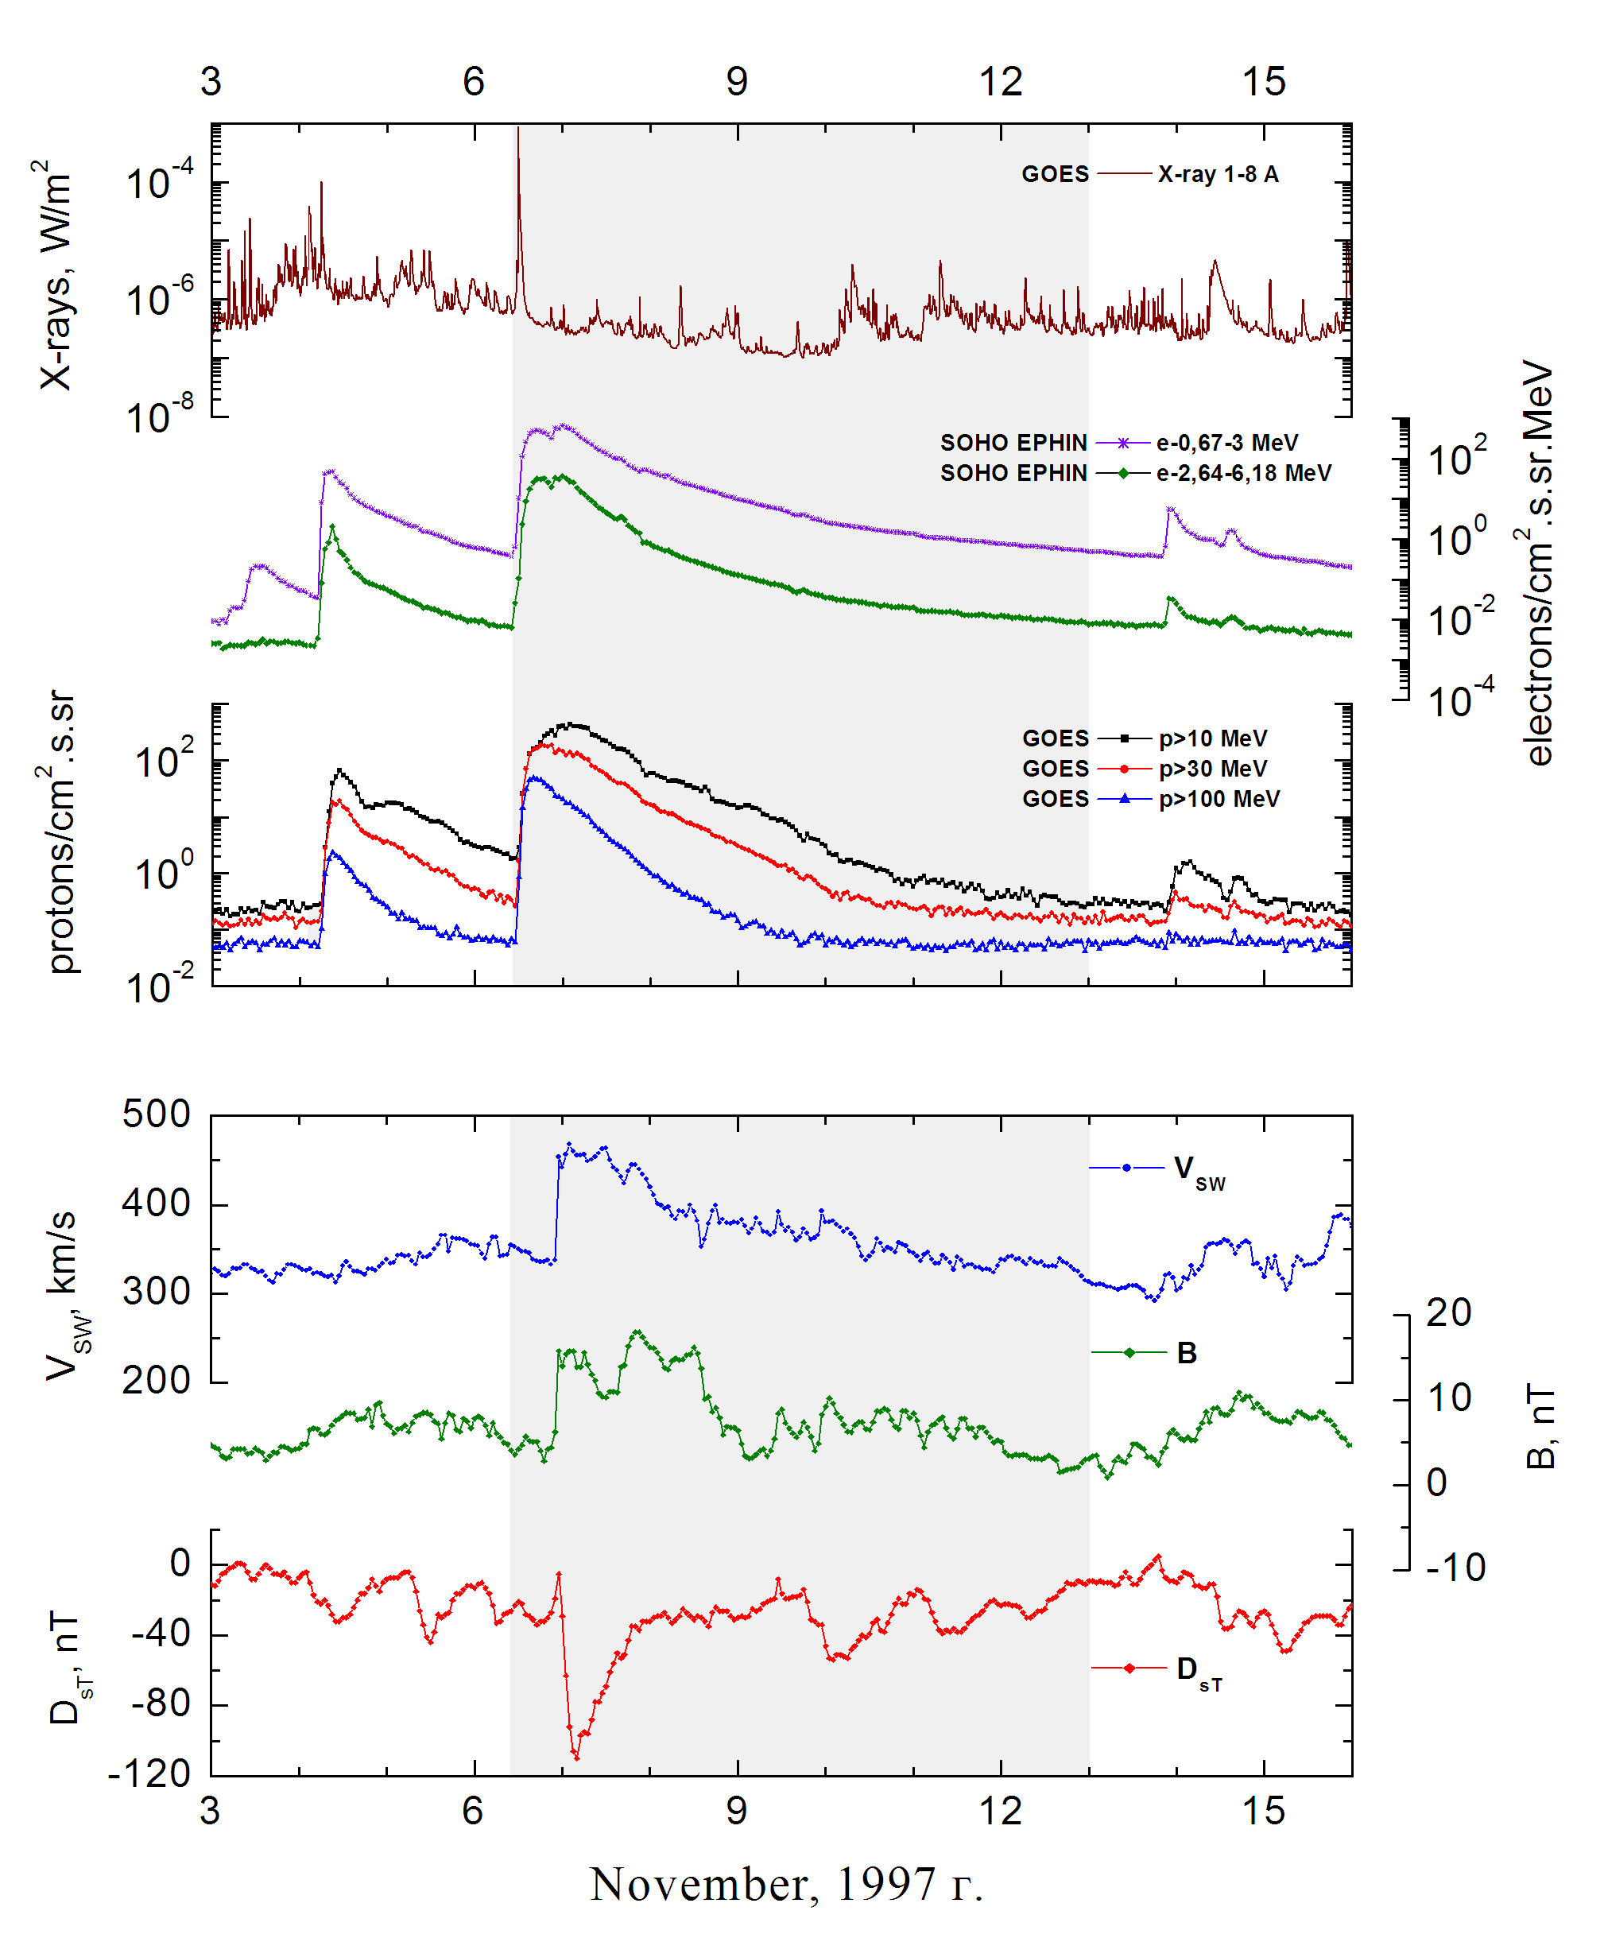

Integral time-of-maximum proton spectrum
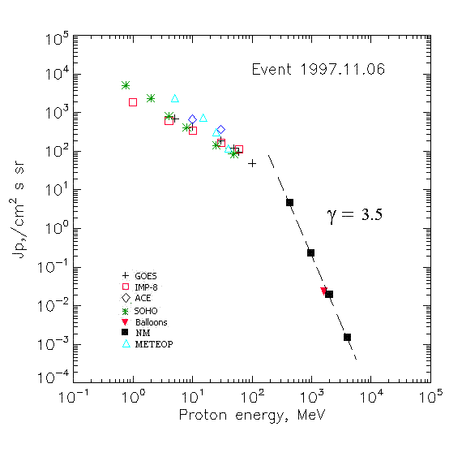

Integral fluxes of protons for the event of 1997 November 06

S/c, instruments | Eр, MeV | To | Tmax | Jmax,  /cm².s.sr | Dura-tion | Comments
GOES 9
EPS | >5 | 13^{h} | 7d07^{h} | 704 | 7d
EPS | >10 | 13^{h} | 7d02^{h} | 432 | 7d
EPS | >30 | 13^{h} | 21^{h} | 187 | 7d
EPS | >50 | 13^{h} | 18^{h} | 119 | 4d
EPS | >60 | 13^{h} | 18^{h} | 95 | 4d
EPS | >100 | 13^{h} | 16^{h} | 49 | 3d
METEOR-2
CBM | >5 | <13^{h} | 7d00^{h} | 2360 | 7d
CBM | >15 | <13^{h} | 7d00^{h} | 740 | 7d
CBM | >25 | <13^{h} | 7d00^{h} | 315 | 6d
CBM | >40 | <13^{h} | 7d00^{h} | 119 | 4d
BP | >90 | 11^{h} | - | - | -
ChD | >600 | 11^{h} | - | - | -
IMP-8
CPME | >1 | 12^{h} | 7d07^{h} | 1840 | 6d
CPME | >4 | 12^{h} | 7d06^{h} | 620 | 6d
CPME | >10 | 11^{h} | 23^{h} | 348 | 6d
CPME | >30 | 11^{h} | 18^{h} | 165 | 6d
CPME | >60 | 11^{h} | 18^{h} | 110 | 6d
ACE
SIS | >10 | 12^{h} | 21^{h} | 670 | 6d
SIS | >30 | 12^{h} | 18^{h} | 370 | 6d
SOHO
EPHIN (INT) | >50 | 13^{h} | 18^{h} | 84 | 6d
BALLOОNS
Mo | >1630 |  | 16^{h} | 0.023
NM
Network | >433 |  | 14^{h} | 4.6
Network | >1000 |  | 14^{h} | 0.23
Network | >2000 |  | 14^{h} | 0.019
Network | >3700 |  | 14^{h} | 0.002

Differential fluxes of protons for the event of 1997 November 06

S/c, instruments | ∆Е, MeV | To | Tmax | Jmax. /cm².s.sr.MeV | Dura-tion | Comments
IMP-8
CPME | 1-2 |  | 07d09^{h} | 700 | 6d
CPME | 2-4.6 |  | 07d07^{h} | 250 | 6d
CPME | 4.6-15 |  | 07d01 ^{h} | 30 | 6d
CPME | 15-25 |  | 07d01^{h} | 11 | 6d
CPME | 25-48 |  | 07d00^{h} | 3 | 6d
CPME | 48-96 |  | 07d00^{h} | 0.8 | 6d
CPME | 96-145 |  | 07d01^{h} | 0.5 | 6d
CPME | 145-440 |  | 07d01^{h} | 0.12 | 6d
SOHO
LION | 0.75-2 | 19^{h} | 07d06^{h} | 1560 | 6d
LION | 2-6 | 19^{h} | 07d06^{h} | 392 | 6d
EPHIN | 4-8 | 19^{h} | 07d06^{h} | 97 | 6d
EPHIN | 8-25 | 19^{h} | 07d02^{h} | 16 | 6d
EPHIN | 25-41 | 19^{h} | 07d02^{h} | 2.8 | 6d
EPHIN | 41-53 | - “ - | - “ - | - “ - | - “ -

References
Lario D., R.G. Marsden, T.R. Sanderson, et al.,1998.
Mason G.M., C.M.S. Cohen, A.C. et al.,1999.
Mason G.M., C.M.S. Cohen, A.C. Cummings, et.al, 1999.
Möbius E.,M. Popecki, B. Klecker, et.al., 1999.
Mazur J.E., G.M. Mason, M.D. Looper, et.al., 1999.
Yoshimori M., A. Shiozawa, and K. Suga. 1999.
Reames D.V., C.K. Ng, A.J. Tylka, 1999.
Matsubara Y., Y. Muraki, T. Sako et al., 1999.
Dietrich W. and C. Lopate., 1999.
Cohen C.M.S., A.C. Cummings, R.A. Leske, et.al., 1999.
Leske R.A., C.M.S. Cohen, A.C. Cummings, et.al., 1999.
Ryan J.M. for Milargo collaboration., 2000.
Yoshimori M., K. Suga, and A. Shiozawa., 2000.
Leske R.A., R.A. Mewaldt, A.C. Cummings, et.al., 2001.
Stovpyuk M.F. and V. M. Ostryakov. 2001
Kuzhevskij B.M., L.I. Miroshnichenko, and E.V. Troitskaia., 2001.
Kuzhevskij B.M., L.I. Miroshnichenko, and E.V. Troitskaia., 2002.
Nitta N.V., E.W. Cliver, A.J. Tylka, and P. Smit, 2003.
Struminsky A.B 2003.
Kuzhevskij B.M., L.I. Miroshnichenko, and E.V. Troitskaja., 2005.
Kuzhevskij B.M., L.I. Miroshnichenko, E.V. Troitskaia, et.al., 2005.
Storini M., K. Kudela, E.G. Cordaro, et.al., 2005.
Wang R. and J Wang. 2006.
Miroshnichenko L.I. and J. Perez-Peraza. 2008.
Mu J., J.S. Wang, H.J. Zhao, et.al., 2010.
Miroshnichenko L.I. and W.Q. Gan. 2012.

