Event 1998.08.24 – (1998-236)

Particle event: To(Ep>10 MeV) – 24d23^{h}
Tmax₁(Ep>10 MeV) – 25d02^{h}, Jmax₁(Ep>10 MeV) – 320 /cm².s.sr
Tmax₂(Ep>10 MeV) – 26d07^{h}, Jmax₂(Ep>10 MeV) – 210 /cm².s.sr
Duration of the event – 6 days
Energy of the SCR and 0.1 GCR fluxes balance – Eb(max₁) = 720 MeV
– Eb(max₂) = 310 MeV
Sources: ● solar flare 24d21^{h}48^{m}, 3B/X1.0, N35E09, АR8307
Main burst X-ray 1-8 Ǻ: onset – 24d21^{h}50^{m}, max – 24d22^{h}12^{m}, Ф = 0.16 J/m²
CME: gap
Particle fluxes and associated phenomena
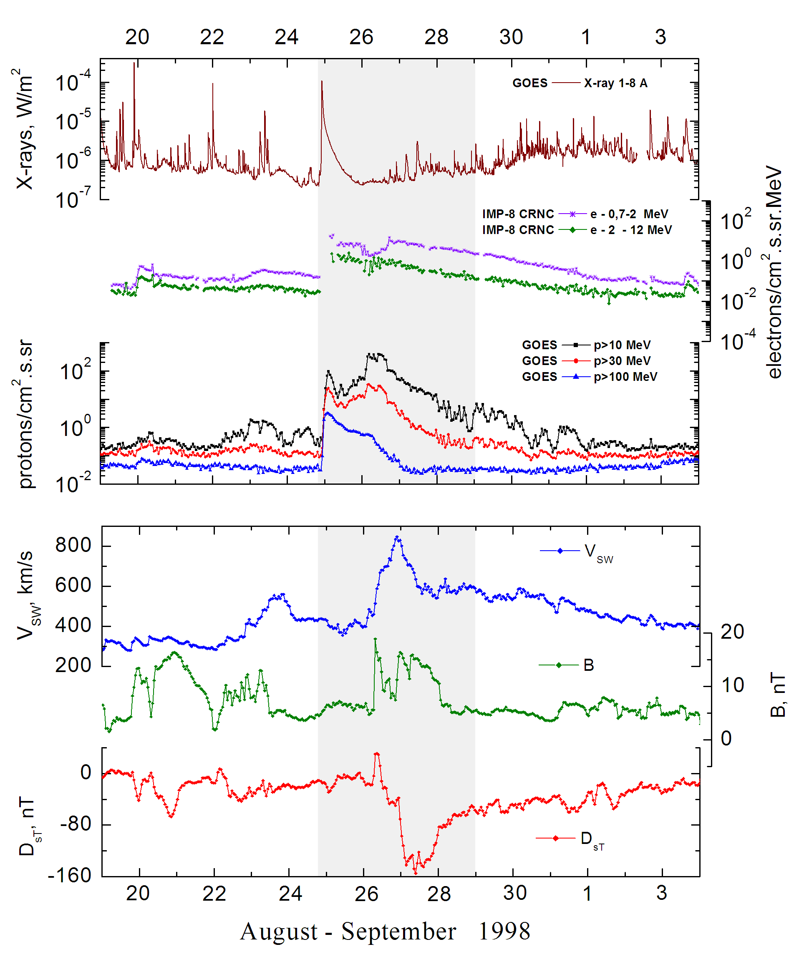
Integral time-of-maximum proton spectrum 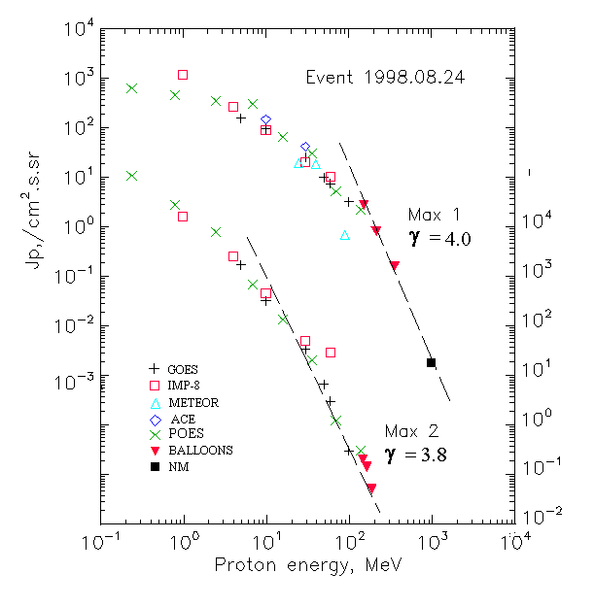

Integral fluxes of protons for the event of 1998 August 24

S/c, instruments | Eр, MeV | To | Tmax | Jmax,  /cm².s.sr | Dura-tion | Comments
GOES-10
EPS | >5 | 23^{h} | 25d02^{h}/26d07^{h} | 158/1730 | 6d
EPS | >10 | 23^{h} | 25d02^{h}/26d07^{h} | 96/320 | 6d
EPS | >30 | 23^{h} | 25d02^{h}/26d04^{h} | 25/34 | 3d
EPS | >50 | 23^{h} | 25d02^{h}/26d04^{h} | 10/6.7 | 2d
EPS | >60 | 23^{h} | 25d02^{h}/26d04^{h} | 7.5/3 | 2d
EPS | >100 | 23^{h} | 25d01^{h}/26d04^{h} | 3.2/0.3 | 2d
METEOR-2
CBM | >5 | - | - | - | -
CBM | >15 | - | - | - | -
CBM | >25 | 23^{h} | 25d < 22^{h}/- | >19/ - | 5d
CBM | >40 | 23^{h} | 25d < 21^{h}/- | >18.5/ - | 3d
BP | >90 | - | 25d < 21^{h}/- | >0.7/ - | -
ChD | >600 | - | - | - | -
POES-15
MEPED | >0.24 | 23^{h} | 25d00^{h}/26d07^{h} | 630/108600 | -
MEPED | >0.8 | 23^{h} | 25d00^{h}/26d07^{h} | 460/28000 | -
MEPED | >2.5 | 23^{h} | 25d00^{h}/26d07^{h} | 350/8000 | -
MEPED | >6.9 | 23^{h} | 25d00^{h}/26d07^{h} | 300/700 | -
MEPED | >16 | 23^{h} | 25d00^{h}/26d07^{h} | 65.1/135.1 | -
MEPED | >36 | 23^{h} | 25d00^{h}/26d07^{h} | 30/20.5 | -
MEPED | >70 | 23^{h} | 25d00^{h}/26d07^{h} | 5.23/1.25 | -
MEPED | >140 | 23^{h} | 25d00^{h}/26d07^{h} | 2.24/0.28 | -
IMP-8
CPME | >1 | >20^{h} | 25d08^{h}/26d07 ^{h} | 1180/16000 | 7d
CPME | >4 | >20^{h} | 25d08^{h}/26d07 ^{h} | 270/2590 | 7d
CPME | >10 | >20^{h} | 25d08^{h}/26d07 ^{h} | 90/455 | 5d
CPME | >30 | >20^{h} | 25d08^{h}/26d07 ^{h} | 20,3/50, | 4d
CPME | >60 | >20^{h} | 25d08^{h}/26d07 ^{h} | 10.5/29 | 4d
ACE
SIS | >10 | 23^{h} | 25d03^{h}/ - | 150/ - | -
SIS | >30 | 23^{h} | 25d01^{h}/ - | 42/ - | -
BALLOОNS
Mi | >154 |  | 25d(08^{h}-09^{h})/ - | 2.7/ -
Mi | >215 |  | 25d(08^{h}-09^{h})/ - | 0.8/ -
Mi | >357 |  | 25d(08^{h}-09^{h})/ - | 0.16/ -
Mi | >150 |  | - /26d(07^{h}-07^{h}) | - /0.2
Mi | >164 |  | - /26d(07^{h}-07^{h}) | - /0.14
Mi | >189 |  | - /26d(07^{h}-07^{h}) | - /0.05
NM
Network | >1000 |  | 25d01^{h}/ - | 1.75·10⁻⁰³/ -

Differential fluxes of protons for the event of 1998 August 24

S/c, instruments | ∆Е, MeV | To | Tmax | Jmax. /cm².s.sr.MeV | Dura-tion | Comments
 |  |  | Protons
IMP-8
CPME | 1-2 | >20^{h} | 25d08^{h}/26d07^{h} | 479/8340 | 6d
CPME | 2-4.6 | >20^{h} | 25d08^{h}/26d07^{h} | 192/2220 | 6d
CPME | 4.6-15 | >20^{h} | 25d08^{h}/26d07^{h} | 17,4/179 | 6d
CPME | 15-25 | >20^{h} | <25d04^{h}/26d07^{h} | 3,4/14,7 | 2d
CPME | 25-48 | >20^{h} | <25d04^{h}/26d07^{h} | 0,5/1,0 | 2d
CPME | 48-96 | >20^{h} | <25d04^{h}/26d07^{h} | 0,14/0,6 | 2d
CPME | 96-145 | >20^{h} | <25d04^{h}/26d07^{h} | 0,09/0,12 | 2d
CPME | 145-440 | >20^{h} | <25d04^{h}/26d07^{h} | 0,01/0,003 | 2d
SOHO |  | Data | absent

References
Dietrich W. and C. Lopate. Measurements of iron reach SEP events using the University of Chicago IMP-8 instrument. - Proc. 26th Int. Cosmic Ray Conf., Salt Lake City, USA, v.6, 71-74, 1999.
Leske R.A., R.A. Mewaldt, .C. Cummings, et.al., 2001.
Struminsky A.B. Prolonged release of > 100 MeV protons from local radiation belts of the Sun. – Proc. 26th Annual Seminar “Physics of Auroral Phenomena”, Apatity, Russia, p.162-165, 2003.
Miroshnichenko L.I. and J. Perez-Peraza. 2008.

