Event 1999.05.04 – (1999-124)

Particle event: To(Ep>10 MeV) – 04d08^{h}
Tmax₁(Ep>10 MeV) – 05d21^{h}, Jmax₁ (Ep>10 MeV) – 3.7 /cm².s.sr
Tmax₂(Ep>10 MeV) – 06d06^{h}, Jmax₂ (Ep>10 MeV) – 4 /cm².s.sr
Duration of the event – 4 days
Energy of the SCR and 0.1 GCR fluxes balance – Eb(max₁) = 75 MeV
– Eb(max₂) = 65 MeV
Sources: ʘ solar flare 03d05^{h}36^{m}, M4.4/2N, N15E32, АR8525
Main X-ray burst 1-8 Ǻ: onset – 03d 05^{h}36^{m}, max – 03d 06^{h} 02^{m}, Ф = 0.099 J/m²
CME: 03d06^{h}06^{m}, V = 1584 km/s, Δφ = 360º, dA = 088º
▲SC 05d15^{h} 43^{m}
Particle fluxes and associated phenomena 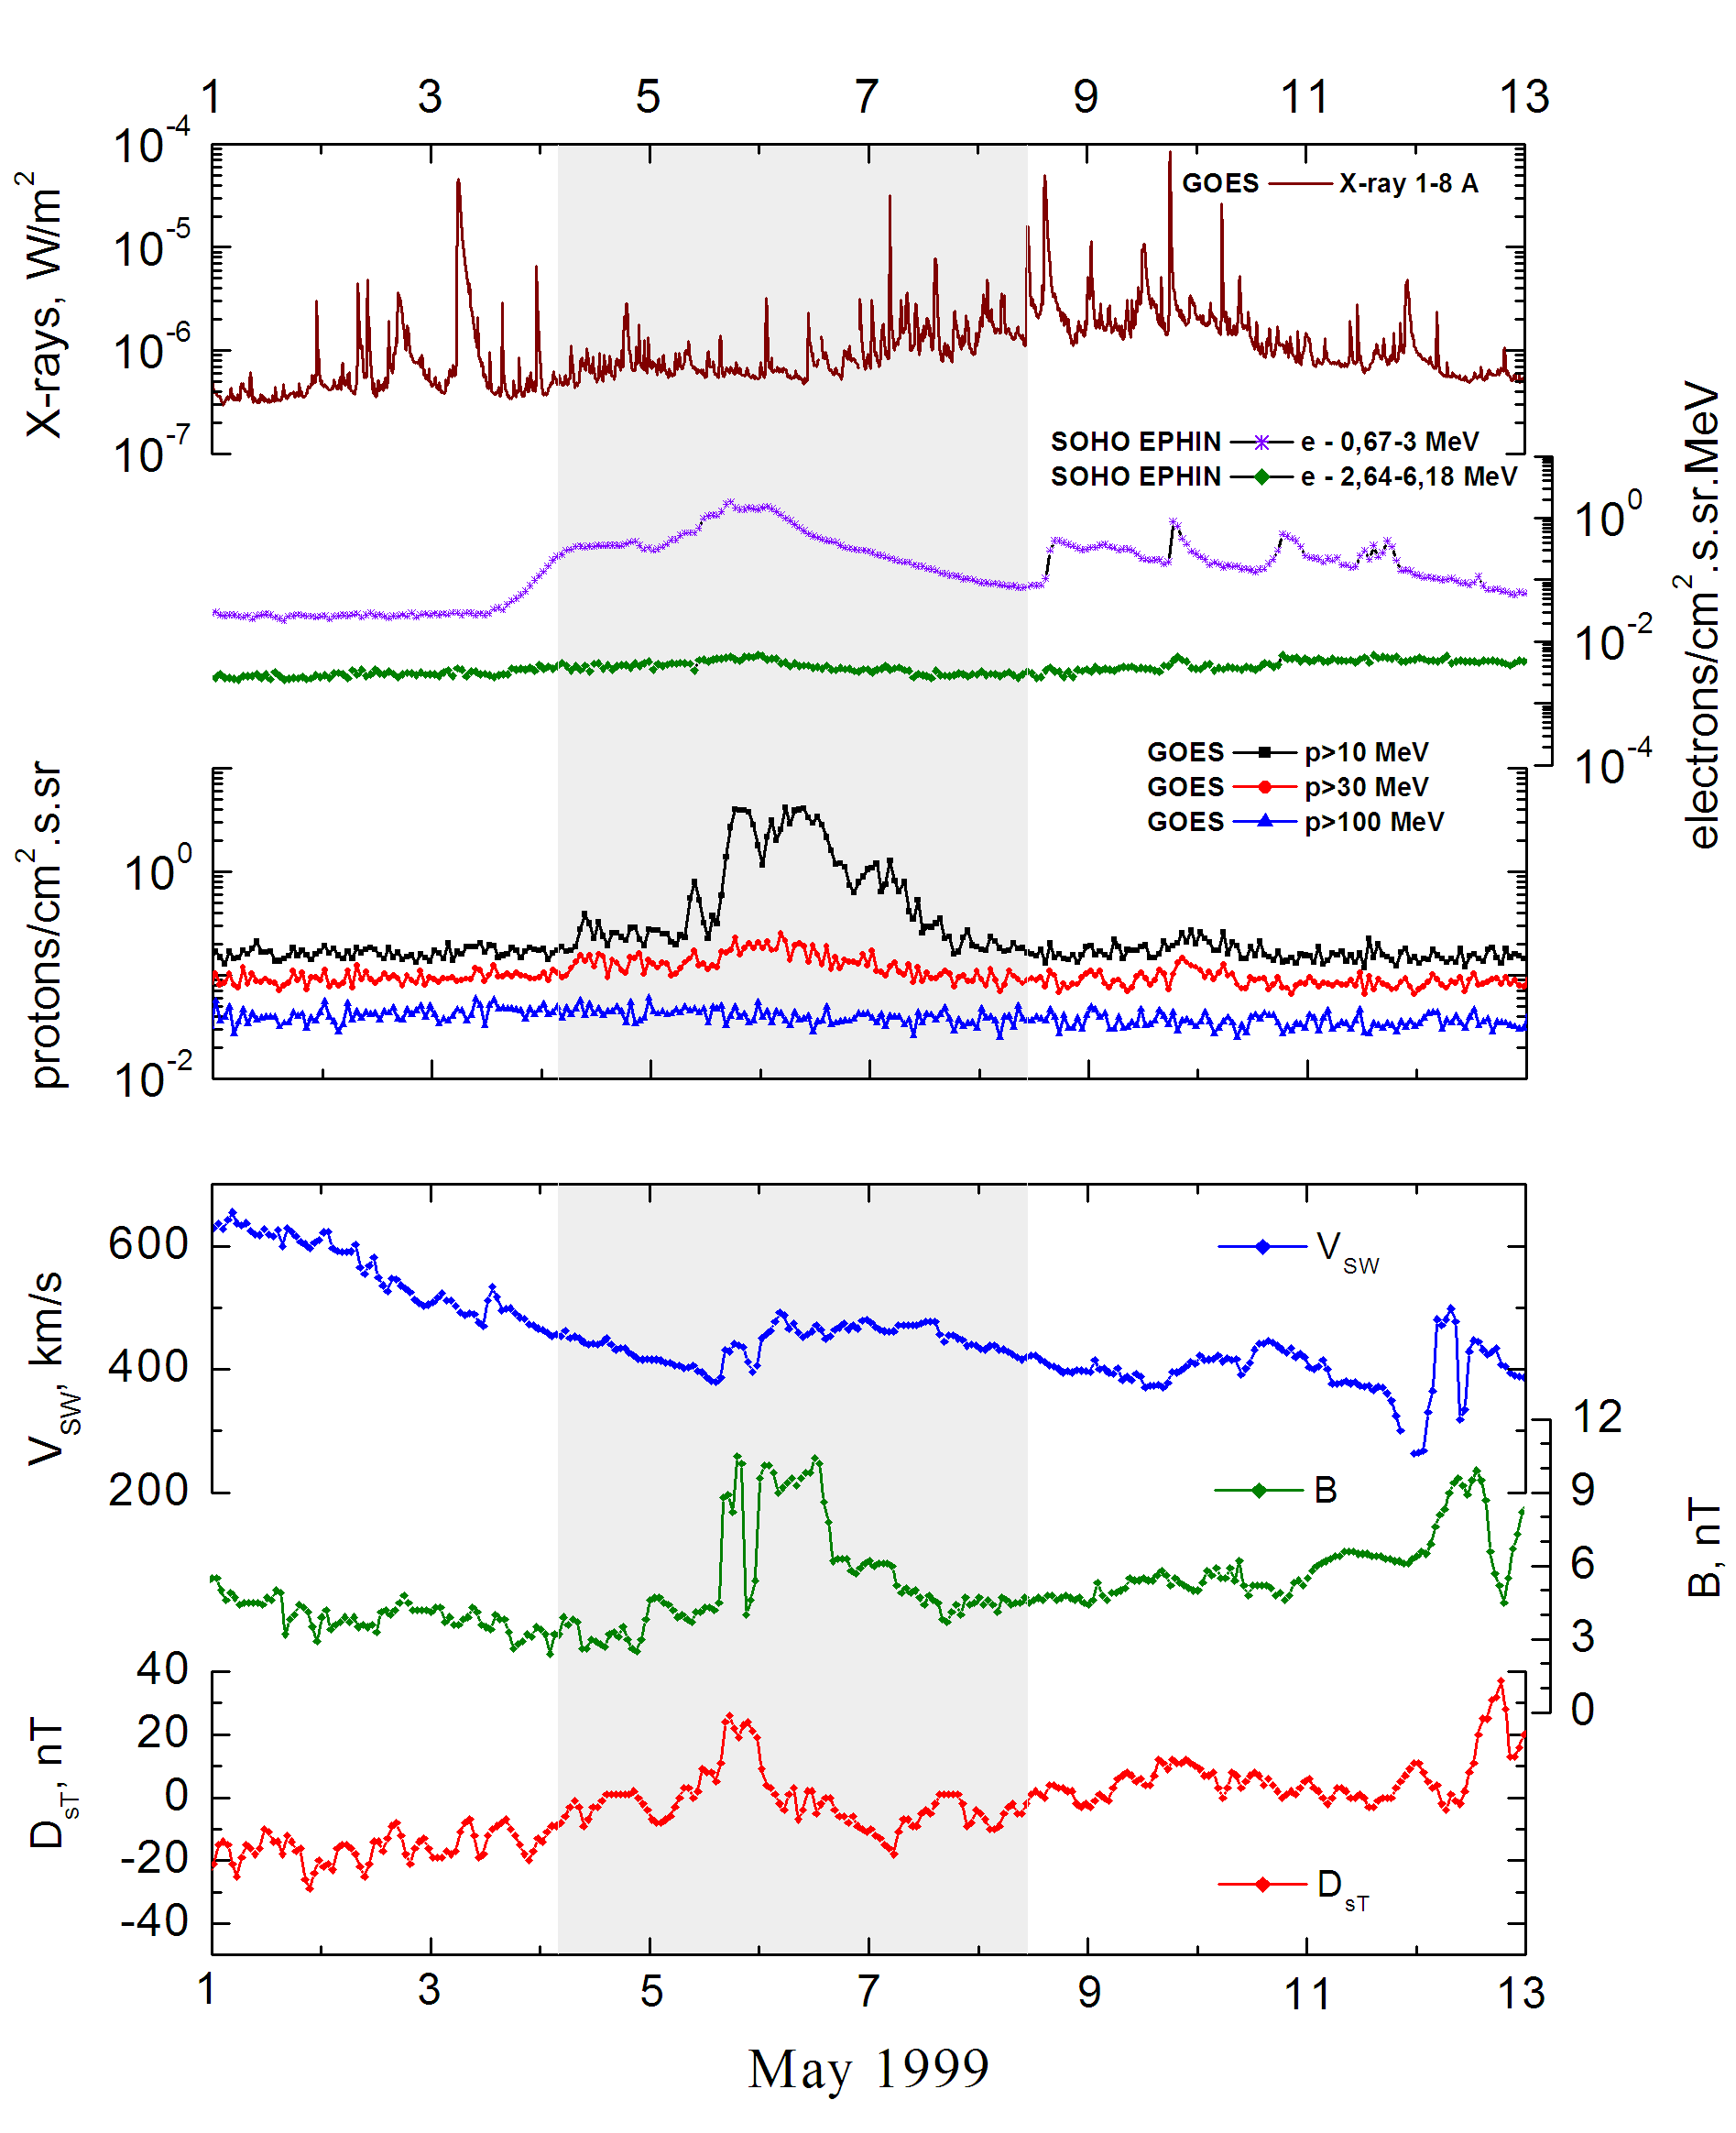
Integral time-of-maximum proton spectrum 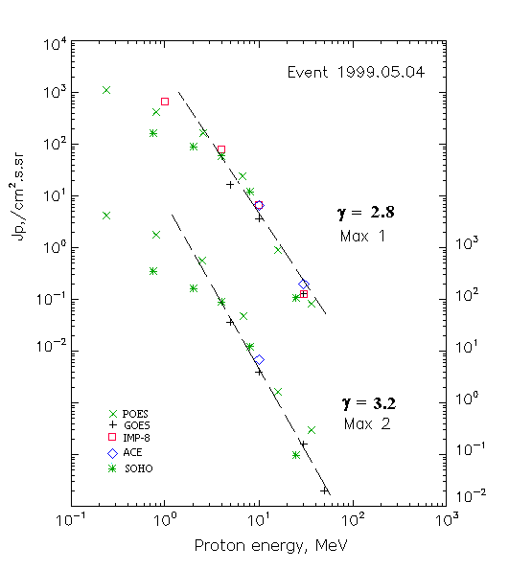

Integral fluxes of protons for the event of 1999 May 04

S/c,  instruments | Eр, MeV | To | Tmax | Jmax,  /cm².s.sr | Dura-tion | Comments
GOES-10
EPS | >5 | 08^{h} | 05d21^{h}/06d09^{h} | 17/36 | 4d
EPS | >10 | 08^{h} | 05d19^{h}/06d06^{h} | 3.7/4 | 4d
EPS | >30 | 07^{h} | 05d18^{h}/06d04^{h} | 0.13 /0.16 | 3d
EPS | >50 | - | - /06d04^{h} | - /0.02 | 1d
EPS | >60 | - | - | - | -
EPS | >100 | - | - | - | -
POES-15
MEPED | >0.24 | - | 05d16^{h}/06d03^{h} | 1120/4280 | 4d
MEPED | >0.8 | - | 05d16^{h}/06d03^{h} | 430/1940 | 4d
MEPED | >2.5 | - | 05d16^{h}/06d03^{h} | 190/570 | 4d
MEPED | >6.9 | - | 05d16^{h}/06d03^{h} | 25/48 | 4d
MEPED | >16 | - | 05d16^{h}/06d03^{h} | 0.9/1.6 | 3d
MEPED | >36 | - | 05d16^{h}/06d03^{h} | 0.08/0.3 | 1d
MEPED | >70 | - | - | - | -
MEPED | >140 | - | - | - | -
IMP-8
CPME | >1 | 02^{h} | 05d19^{h}/ - | 660/ - | 7 d
CPME | >4 | 02^{h} | 05d19^{h}/ - | 80/ - | 7 d
CPME | >10 | 02^{h} | 05d19^{h}/ - | 6.8/ - | 6 d
CPME | >30 | 01^{h} | 05d19^{h}/ - | 0.13/ - | -
CPME | >60 | - | - | - / - | -
ACE
SIS | >10 | 03d18^{h} | 05d19^{h}/06d02^{h} | 6.6/6.8 | 6d
SIS | >30 | 03d18^{h} | 05d15^{h}/ - | 0.2/ - | 3d
SOHO
EPHIN (INT) | >50 | 03d18 | Forbush effect | Forbush effect | 4d

Differential fluxes of protons for the event of 1999 May 04

S/c, instruments | ∆Е, MeV | To | Tmax | Jmax  /cm².s.sr.MeV | Dura-tion | Comments
IMP-8
CPME | 1-2 | 03d12^{h} | 05d15^{h}/ - | 348/ - | 7d
CPME | 2-4.6 | 03d16^{h} | 05d15^{h}/ - | 92/ - | 7d
CPME | 4.6-15 | 03d20^{h} | 05d19^{h}/ - | 6,3/ - | 5d
CPME | 15-25 | 01^{h} | 05d19^{h}/ - | 0,18/ - | ∼4d
CPME | 25-48 | - | - | - | -
CPME | 48-96 | - | - | - | -
CPME | 96-145 | - | - | - | -
CPME | 145-440 | - | - | - | -
SOHO
LION | 0,75-2 | 03d22^{h} | 05d18^{h}/06d04^{h} | 42/106 | 6d
LION | 2-6 | 02^{h} | 05d18^{h}/06d03^{h} | 7.3/18 | 6d
EPHIN | 4-8 | 03d14^{h} | 05d18^{h}/06d02^{h} | 12/19 | 6d
EPHIN | 8-25 | 03d14^{h} | 05d18^{h}/06d02^{h} | 0.7/0.72 | 6d
EPHIN | 25-41 | 03d14^{h} | 05d18^{h}/06d02^{h} | 0.0035/0.0018 | 5d
EPHIN | 41-53 | - “ - | - “ - | - “ - | - “ -

References:
No information on publications, excepting for:
http://www.swpc.noaa.gov/ftpdir/indices/SPE.txt

