Event 1999.06.04 – (1999-155)

Particle event: To(Ep>10 MeV) – 04d08^{h}
Tmax(Ep>10 MeV) – 04d12^{h}, Jmax (Ep>10 MeV) – 20 /cm².s.sr
Duration of the event – 3 days
Energy of the SCR and 0.1 GCR fluxes balance – Eb = 300 MeV

Sources: ● solar flare 04d06^{h}52^{m}, M3.9/2N, N18W72, АR8552
Main X-ray burst 1-8 Ǻ: onset – 04d06^{h}52^{m}, max – 04d07^{h}03^{m}, Ф = 0.024 J/m²
CME: 04d07^{h}27^{m}, V = 2230 km/s, Δφ = 150 º, dA= 287º

Particle fluxes and associated phenomena
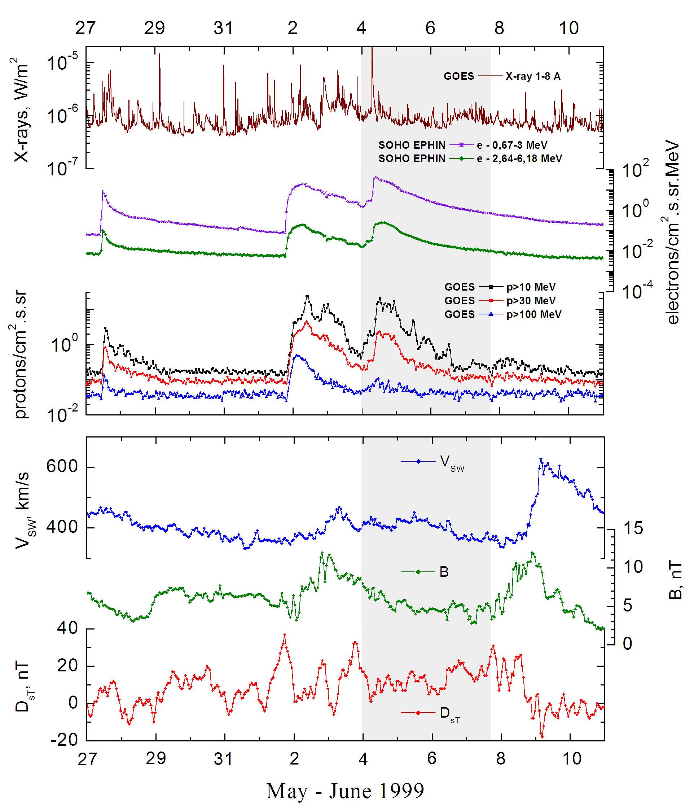

Integral time-of-maximum proton spectrum 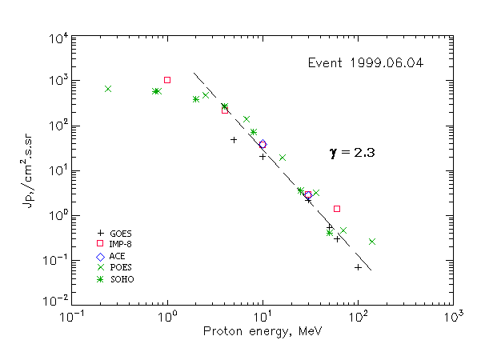

Integral fluxes of protons for the event of 1999 June 04

S/c, instruments | Eр, MeV | To | Tmax | Jmax,  /cm².s.sr | Dura-tion | Comments
GOES-10
EPS | >5 | 08^{h} | 13 ^{h} | 48 | 3d
EPS | >10 | 08^{h} | 12^{h} | 20 | 3d
EPS | >30 | 08^{h} | 12^{h} | 2.2 | 3d
EPS | >50 | 08^{h} | 11^{h} | 0.55 | 3d
EPS | >60 | - | 11^{h} | 0.3 | 2d
EPS | >100 | - | 11^{h} | 0.07 | 2d
POES-15
MEPED | >0.24 | - | 12^{h} | 615 | 3d
MEPED | >0.8 | - | 12^{h} | 540 | 3d
MEPED | >2.5 | - | 12^{h} | 430 | 3d
MEPED | >6.9 | - | 12^{h} | 170 | 3d
MEPED | >16 | - | 12^{h} | 19.72 | 3d
MEPED | >36 | - | 12^{h} | 3.27 | 3d
MEPED | >70 | - | 12^{h} | 0.46 | 2d
MEPED | >140 | - | 12^{h} | 0.26 | 2d
IMP-8
CPME | >1 | 09^{h} | 20^{h} | 1020 | 5 d
CPME | >4 | 09^{h} | 17^{h} | 220 | 5 d
CPME | >10 | 09^{h} | 16^{h} | 37 | 5 d
CPME | >30 | 09^{h} | 13^{h} | 2.9 | 2 d
CPME | >60 | 09^{h} | 12^{h} | 1.4 | 2 d
ACE
SIS | >10 | 09^{h} | 16^{h} | 39 | 4d
SIS | >30 | 09^{h} | 13^{h} | 2.8 | 1d
SOHO
EPHIN (INT) | >50 | 09^{h} | 12^{h} | 0.41 | <1d

Differential fluxes of protons for the event of 1999 June 04

S/c, instruments | ∆Е, MeV | To | Tmax | Jmax  /cm².s.sr.MeV | Dura-tion | Comments
IMP-8
CPME | 1-2 | 10^{h} | 23^{h} | 560 | 5d
CPME | 2-4.6 | 09^{h} | 19^{h} | 188 | 5d
CPME | 4.6-15 | 09^{h} | 16^{h} | 17 | 5d
CPME | 15-25 | 07^{h} | 14^{h} | 1.2 | 5d
CPME | 25-48 | 09^{h} | 13^{h} | 0,1 | 4d
CPME | 48-96 | 08^{h} | 12^{h} | 0,01 | 2d
CPME | 96-145 | 08^{h} | - | - | 1d
CPME | 145-440 | 06^{h} | 10^{h} | 0,002 | 1d
SOHO
LION | 0,75-2 | 10^{h} | 23^{h} | 110 | 4d
LION | 2-6 | 10^{h} | 17^{h} | 28 | 4d
EPHIN | 4-8 | 09^{h} | 15^{h} | 49.7 | 5d
EPHIN | 8-25 | 09^{h} | 14^{h} | 40.5 | 5d
EPHIN | 25-41 | 09^{h} | 13^{h} | 0.1 | 5d
EPHIN | 41-53 | - ‘ - | - ‘ - | - ‘ - | - ‘ -

References:
No information on publications, excepting for:
http://www.swpc.noaa.gov/ftpdir/indices/SPE.txt

