Event 1999.06.11 − (1999-162)

Particle event: To(Ep>10 MeV) – 11d01^{h}
Tmax(Ep>10 MeV) – 11d03^{h}, Jmax (Ep>10 MeV) – 2.2 /cm².s.sr *)
Duration of the event – 10 hours
Energy of the SCR and 0.1 GCR fluxes balance – Eb = 240 MeV
*) From CPME s/c IMP-8

Sources: □ solar flare 11d01^{h}05^{m}, C1.0/…, АR behind the limb
Main X-ray burst 1-8 Ǻ: onset: – 11d01^{h}05^{m}, max – 11d01^{h}10^{m}, Ф = 0.00061 J/m²
CME: 11d01^{h}27^{m}, V = 0719 km/s, Δφ = 101º, dA = 288º

Particle fluxes and associated phenomena
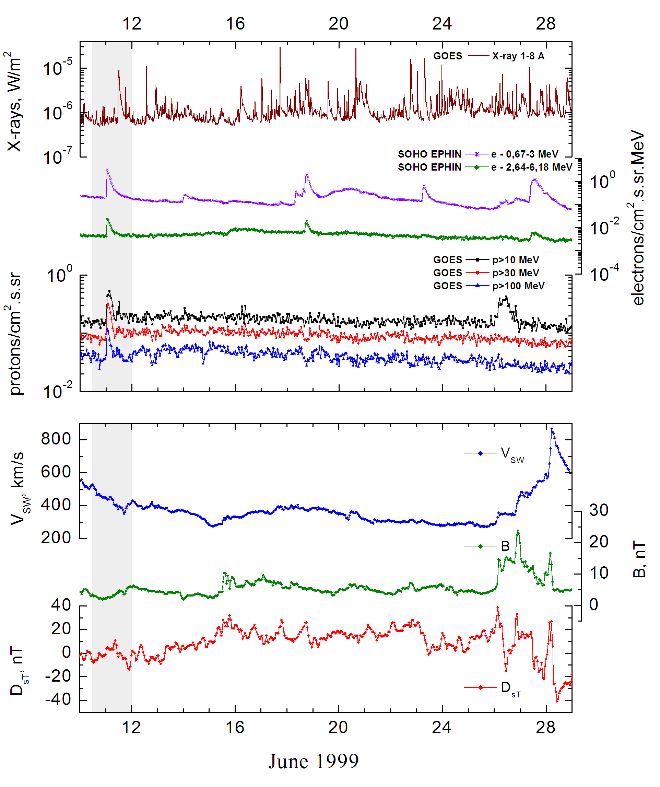

Integral time-of-maximum proton spectrum 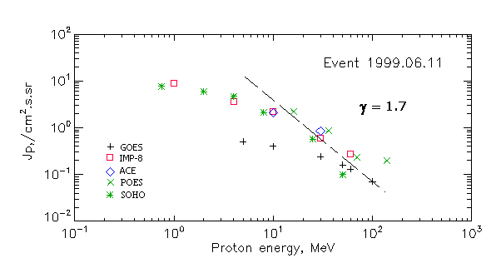

Integral fluxes of protons for the event of 1999 June 11

S/c, instruments | Eр, MeV | To | Tmax | Jmax,  /cm².s.sr | Dura-tion | Comments
GOES-10
EPS | >5 | 01^{h} | 03^{h} | 0.5 | 10 h
EPS | >10 | 00^{h} | 03^{h} | 0.4 | 10 h
EPS | >30 | 00^{h} | 02^{h} | 0.24 | 10 h
EPS | >50 | 00^{h} | 02^{h} | 0.16 | 10 h
EPS | >60 | 00^{h} | 02^{h} | 0.13 | 8 h
EPS | >100 | 00^{h} | 01^{h} | 0.07 | 6 h
POES-15
MEPED | >0.24 | - | - | - | -
MEPED | >0.8 | - | - | - | -
MEPED | >2.5 | - | - | - | -
MEPED | >6.9 | - | - | - | -
MEPED | >16 | - | 02^{h} | 2.21 | 10 h
MEPED | >36 | - | 02^{h} | 0.88 | 10 h
MEPED | >70 | - | 02^{h} | 0.23 | 8 h
MEPED | >140 | - | 02^{h} | 0.2 | 6 h
IMP-8
CPME | >1 | 01^{h} | 06^{h} | 9 | 10 h
CPME | >4 | 01^{h} | 04^{h} | 3.6 | 10 h
CPME | >10 | 01^{h} | 03^{h} | 2.2 | 10 h
CPME | >30 | 01^{h} | 02^{h} | 0.6 | 10 h
CPME | >60 | 01^{h} | 02^{h} | 0.28 | 10 h
ACE
SIS | >10 | 01^{h} | 02^{h} | 2.1 | 10 h
SIS | >30 | 01^{h} | 02^{h} | 0.85 | 8 h
SOHO
EPHIN (INT) | >50 | 01^{h} | 02^{h} | 0.1 | 10 h

Differential fluxes of protons for the event of 1999 June 11

S/c, instruments | ∆Е, MeV | To | Tmax | Jmax  /cm².s.sr.MeV | Dura-tion | Comments
IMP-8
CPME | 1-2 | 04^{h} | 06^{h} | 4 | 15h
CPME | 2-4.6 | 04^{h} | 05^{h} | 1.5 | 15h
CPME | 4.6-15 | 04^{h} | 03^{h} | 0.22 | 15h
CPME | 15-25 | 03^{h} | 02^{h} | 0.11 | 12h
CPME | 25-48 | - | 02^{h} | 0.018 | 10h
CPME | 48-96 | - | 01^{h} | 0.007 | 10h
CPME | 96-145 | - | 02^{h} | 0.004 | 8h
CPME | 145-440 | - | 01^{h} | 0.0003 | 8h
SOHO
LION | 0,75-2 | 01^{h} | 06^{h} | 1 | ∼1d
LION | 2-6 | 01^{h} | 05^{h} | 0,3 | ∼1d
EPHIN | 4-8 | 01^{h} | 03^{h} | 0.64 | 1,5d
EPHIN | 8-25 | 01^{h} | 02^{h} | 0.1 | 1d
EPHIN | 25-41 | 01^{h} | 02^{h} | 0.015 | 1d
EPHIN | 41-53 | - “ - | - “ - | - “ - | - “ -

References:
No information on publications, excepting for:
http://www.swpc.noaa.gov/ftpdir/indices/SPE.txt

